33333333

Hydraulic Analysis Technical Support Data Notebook
Task Order HSFE02-11-J-0001 for Esopus Watershed Hydraulic Study, New York
FEMA Contract No. HSFEHQ-09-D-0369
June 2013


Federal Emergency Management Agency
Region II
26 Federal Plaza, Suite 1337
New York, NY 10278

NYC WHO Watershed Study
Hydraulic Analysis Report
Esopus Watershed

Esopus Creek
Beaver Kill
Birch Creek
Broadstreet Hollow
Bush Kill
Bushnellsville Creek
Fox Hollow
Little Beaver Kill
Stony Clove Creek
Woodland Creek
and tributaries of these streams

June 4, 2013
RAMPP
Dewberry
Fairfax, VA

TABLE OF CONTENTS
I. Introduction 1
II. Study Area 11
III. Effective Flood Insurance Studies 16
IV. Other Flood Studies 17
V. Flooding History 17
VI. Discharges 19
VII. Survey and Cross Section Development 20
VIII. Boundary conditions and Tie-ins 22
IX. Structures 24
X. Ineffective and Storage Areas 25
XI. Channel and Overbank Roughness Values 25
XII. Split Flow/Diverted Flow Modeling 27
XIII. Calibration 27
XIV. Floodway 49
XV. Results 50
XVI. References 53

INDEX OF FIGURES
Figure 1: Esopus Watershed boundary with scoped flooding sources and labeled sub-watersheds. 5
Figure 2: Esopus Watershed boundary and scoped flooding sources with Esopus Creek and major tributaries labeled. 6
Figure 3: Scoped Flooding Sources – Part1 7
Figure 4: Scoped Flooding Sources – Part2 8
Figure 5: Scoped Flooding Sources – Part3 9
Figure 6: Scoped Flooding Sources – Part4 10
Figure 7: New York City Water Supply System (Source: NYCDEP, 2011). 12
Figure 8: USGS rating curve at streamgage 013621955: Birch Creek at Big Indian, NY, and simulated WSELs for Birch Creek. 30
Figure 9: Observed and modeled stream flows and corresponding WSELs at Bush Kill stream gage. 31
Figure 10: Simulated vs. observed comparison at USGS gage 01362200 on Esopus Creek 33
Figure 11: Simulated vs. observed comparison at USGS gage 01362500 on Esopus Creek 34
Figure 12: Location of High Water Marks D1_1 and D1_2 on Esopus Creek 35
Figure 13: Location of High Water Marks D1_17, D1_18, and D1_19 on Esopus Creek 36
Figure 14: Location of High Water Marks D1_3, D1_4, and D1_5 on Esopus Creek 37
Figure 15: Location of High Water Marks D1_9, D1_10, and D1_11 on Esopus Creek 38
Figure 16: Location of High Water Marks D1_22 and D1_23 on Esopus Creek 39
Figure 17: Location of High Water Marks D1_13 and D1_14 on Esopus Creek 40
Figure 18: Comparison of USGS streamgage (Stony Clove Creek below Ox Clove at Chichester, NY) data and simulated WSELs at XS 9861. 42
Figure 19: Comparison of USGS streamgage (Stony Clove Creek near Phoenicia, NY) data and simulated WSELs at XS 7041. 42
Figure 20: Location and elevation of HWMs from Hurricane Irene on Stony Clove Creek near the confluence of Esopus Creek. 44
Figure 21: USGS stream gage data and model results comparison on Hollow Tree Brook. 47
Figure 22: Comparison of USGS 013623002 rating curve and model results at cross section 1213. 49

INDEX OF TABLES
Table 1: Summary of study scope information. 2
Table 2: Number of study reaches and total miles for each study type. 4
Table 3: Number of study reaches and miles of each study type for each county. 4
Table 4: Effective FISs that will be impacted by the current study, along with the effective dates. 17
Table 5: Number of high water marks (HWMs) collected per stream within the Esopus Watershed. 18
Table 6: Active USGS stream gages within the current study limits. 19
Table 7: Number of flow change locations for each sub-watershed and each stream. 19
Table 8: Summary of survey information by stream. 21
Table 9: Number of structures of each type modeled for each stream. 24
Table 10: Summary of channel and overbank n-values for each sub-watershed in the Esopus Watershed. 26
Table 11: USGS stream gages used for calibration. 28
Table 12: High Water Marks (HWMs) used for calibration. 28
Table 13: Comparison of Beaver Kill HWM elevations and modeled WSELs upstream of Mt. Tremper-Phoenecia bridge. 29
Table 14: Peak flows and corresponding WSELs recorded at Bush Kill stream gage from 2001-2011. 31
Table 15: Discharges and WSELs from Bush Kill HEC-RAS model. 31
Table 16: USGS Gages on Esopus Creek 32
Table 17: Comparison of HWM’s and simulated WSEL on Esopus Creek 32
Table 18: Comparison of model results using measured and estimated flows of Hurricane Irene and downstream high water marks. 43
Table 19: Comparison of USGS peak stream flows with model results. 45
Table 20: USGS stream gage 013623002 observed WSELs compared with simulated WSELs at cross section 1213. 48
Table 21: Comparison of proposed and effective FIS 1%-annual chance WSELs. 51

Introduction
This report presents the background, methodology, and results of the hydraulic analyses conducted for approximately 112 miles of stream reaches within the Esopus Watershed in the State of New York. The analyses described in this report were conducted as part of a flood study initiated by The New York City Department of Environmental Protection (NYCDEP) and The Department of Homeland Security’s Federal Emergency Management Agency (FEMA). The purpose of this flood study is to develop new and updated hydraulic analyses and other flood hazard products for selected flooding sources in the Esopus Watershed. The Esopus Watershed includes all streams that eventually drain to the Ashokan Reservoir, including the approximately 23 miles of the main stem, Esopus Creek. The reservoir is located approximately 14 miles west of Kingston, New York.
The scope for the current study included a total of 112 miles of streams and lakes within the Esopus Watershed. The Esopus Watershed was divided into nine tributary watersheds and the Esopus Creek main stem. Table 1 provides the list of all the current study flooding sources grouped by tributary, study type, and mileage. In terms of mileage, the scope includes approximately 98 miles of streams and 14 miles of the reservoir and other lakes. The level of analysis (study type) to be conducted for each of the flooding sources was identified prior to the initiation of the current project during the discovery (scoping) phase. Five different study types were utilized for the current project, which include approximate (A), detailed (D), backwater (B), limited detail (LD), and lake (L). The number of study reaches and total miles for each study type are provided in Table 2.
The hydraulic models developed for the Esopus Watershed were calibrated to High Water Marks (HWMs), where available, that were collected after Hurricane Irene, August 2011. USGS stream gages were also located along a few study reaches. In these cases the stream gage measurements were also used in calibrating the hydraulic models.
The Ashokan Reservoir and Kenozia Lake are located within the Esopus Watershed. These lakes were modeled as a part of the hydrologic analysis. The 1%- and 0.2%-annual chance floodplains were delineated based on the Water Surface Elevations (WSELs) obtained from the HEC-HMS model of the hydrology study. For further details, please refer to the full hydrology report (FEMA, 2013).
The scoped flooding sources for this project span six communities located in two counties in New York. The two counties affected by the current study are Greene and Ulster counties. All of the streams analyzed in the current study are located in Ulster County except for Jay Hand Hollow, Hollow Tree Brook, and portions of Stony Clove Creek, Bushnellsville Creek, and Broadstreet Hollow, which are located in Greene County. Out of the six communities affected by the current study, two are located in Greene County and four are located in Ulster County. The communities located in Greene County are the Towns of Hunter and Lexington, and the communities located in Ulster County are the Towns of Hurley, Olive, Shandaken, and Woodstock. The distribution of study reaches and types for each county is provided in Table 3. The analyses developed for the current study are consistent with FEMA’s Guidelines and Specifications for Flood Mapping Partners (FEMA, 2009(b)). These analyses resulted in the development of 10%-, 4%-, 2%-, 1%-, and 0.2%-annual chance flood profiles, 1%- and 0.2%-annual chance floodplains, and floodways for detailed study reaches, a 1%-annual chance flood profile and floodplain for all limited detail study reaches, and a 1%-annual chance floodplain for approximate study reaches.
All of the hydraulic analyses for this study were performed using HEC-RAS 4.1. All modeling was conducted by RAMPP except for the Greene County portion of Stony Clove Creek. For the Greene County portion of this stream an existing model, provided by New York State Departement of Environmental Conservation (NYSDEC), was utilized. The model was upgraded from HEC-RAS version 3.1.1 to 4.1.0, updated to account for new discharge data and the effects of the detailed hydraulic analysis of the downstream portion of the stream in Ulster County. The update also included a few minor changes to bank locations.
The general locations of the flooding sources studied in this project, divided into the same sub-watersheds as indicated in Table 1, are shown in Figure 1. The same flooding sources are shown in Figure 2, with Esopus Creek and its major tributaries labeled. Figure 3 through Figure 6 provide a detailed view of the scoped flooding sources, in four parts, with each stream reach labeled.
Table 1: Summary of study scope information.
Study Segment (Sub-Watershed, Stream, or Lake) | Stream/Lake Name | HEC-RAS Model | Study Type | Miles | County(s) | Community(s)
Ashokan Reservoir (excluding major tributaries) | AshokanReservoir | N/A | L | 12.8 | Ulster | Olive, Hurley
Ashokan Reservoir (excluding major tributaries) | KenoziaLake | N/A | LD | 0.7 | Ulster | Hurley
Beaver Kill Watershed | BeaverKill | Beaver Kill | D | 6.4 | Ulster | Shandaken, Woodstock
Beaver Kill Watershed | MinkHollowStream | Mink Hollow Stream | D | 3.6 | Ulster | Shandaken
Beaver Kill Watershed | WagnerCreek | Wagner Creek | D | 1.7 | Ulster | Shandaken
Birch Creek Watershed | AltonCreek | Alton Creek | D | 2.1 | Ulster | Shandaken
Birch Creek Watershed | AltonCreek_t1 | Alton Creek Tributary | D | 1.6 | Ulster | Shandaken
Birch Creek Watershed | BirchCreek_s1 | Birch Creek | D | 2.5 | Ulster | Shandaken
Birch Creek Watershed | PineHillLake | Birch Creek | D | 0.2 | Ulster | Shandaken
Birch Creek Watershed | BirchCreek_s2 | Birch Creek | D | 1.0 | Ulster | Shandaken
Birch Creek Watershed | BirchCreek_s3 | Birch Creek | LD | 2.9 | Ulster | Shandaken
Birch Creek Watershed | GiggleHollow | Giggle Hollow | A | 0.2 | Ulster | Shandaken
Broadstreet Hollow Watershed | BroadstreetHollow | Broadstreet Hollow | D | 3.0 | Green, Ulster | Lexington, Shandaken
Broadstreet Hollow Watershed | JayHandHollow | Jay Hand Hollow | A | 2.4 | Greene | Lexington
Bush Kill Watershed | BushKill | Bush Kill | D | 4.7 | Ulster | Olive
Bush Kill Watershed | DryBrook | Dry Brook | D | 3.2 | Ulster | Olive
Bush Kill Watershed | KanapeBrook | Kanape Brook | A | 1.9 | Ulster | Olive
Bush Kill Watershed | MaltbyHollowBrook | Maltby Hollow Brook | D | 2.1 | Ulster | Olive
Bush Kill Watershed | SouthHollowBrook | South Hollow Brook | A | 0.9 | Ulster | Olive
Bushnellsville Creek | BushnellsvilleCreek | Bushnellsville Creek | D | 4.0 | Greene, Ulster | Lexington, Shandaken
Esopus Creek (including minor tributaries) | EsopusCreek | Esopus Creek | D | 22.0 | Ulster | Olive, Shandaken
Esopus Creek (including minor tributaries) | TraverHollow | Traver Hollow | A | 1.1 | Ulster | Shandaken
Esopus Creek (including minor tributaries) | EsopusCreek | EsopusTribs_ZoneAs | A | 1.1 | Ulster | Shandaken
Esopus Creek (including minor tributaries) | EsopusCreek_t7 | EsopusTribs_ZoneAs | A | 0.3 | Ulster | Shandaken
Esopus Creek (including minor tributaries) | PeckHollow | EsopusTribs_ZoneAs | A | 0.2 | Ulster | Shandaken
Esopus Creek (including minor tributaries) | Hatchery Hollow | Hatchery Hollow | LD | 0.6 | Ulster | Shandaken
Esopus Creek (including minor tributaries) | Lost Clove | Lost Clove | A | 0.1 | Ulster | Shandaken
Esopus Creek (including minor tributaries) | McKinley Hollow | McKinley Hollow | LD | 0.2 | Ulster | Shandaken
Fox Hollow | FoxHollow | Fox Hollow | D | 2.0 | Ulster | Shandaken
Little Beaver Kill | LittleBeaverKill | Little Beaver Kill | D | 0.7 | Ulster | Olive, Shandaken
Little Beaver Kill | LittleBeaverKill | Little Beaver Kill | LD | 5.7 | Ulster | Olive, Woodstock
Stony Clove Creek Watershed | HollowTreeBrook | Hollow Tree Brook | D | 1.5 | Greene | Hunter
Stony Clove Creek Watershed | StonyCloveCreek | Stony Clove Creek | D | 8.6 | Greene, Ulster | Hunter, Shandaken
Stony Clove Creek Watershed | WarnerCreek_s1 | Warner Creek | D | 1.9 | Ulster | Shandaken
Woodland Creek Watershed | CrossMountainHollow | Cross Mountain Hollow | B | 0.1 | Ulster | Shandaken
Woodland Creek Watershed | MuddyBrook | Muddy Brook | B | 0.1 | Ulster | Shandaken
Woodland Creek Watershed | PantherKill | Panther Kill | A | 3.3 | Ulster | Shandaken
Woodland Creek Watershed | WoodlandCreek_s1 | Woodland Creek | D | 3.5 | Ulster | Shandaken
Woodland Creek Watershed | WoodlandCreek_s2 | Woodland Creek | A | 0.6 | Ulster | Shandaken
Woodland Creek Watershed | WoodlandCreek_t3 | Woodland Creek Tributary 3 | B | 0.1 | Ulster | Shandaken
Total number of reaches studied |  |  |  | 40
Total Miles |  |  |  | 111.6

Table 2: Number of study reaches and total miles for each study type.
Study Type | Study Reaches | Mileage
Approximate (A) | 10 | 12.1
Backwater (B) | 3 | 0.3
Detailed (D) | 20 | 76.3
Lake (L) | 1 | 12.8
Limited detail (LD) | 6 | 10.1
Total | 40 | 111.6

Table 3: Number of study reaches and miles of each study type for each county.
County | Study Type | Mileage
Greene | Approximate (A) | 2.4
Greene | Detailed (D) | 8.6
Greene Total |  | 11.0
Ulster | Approximate (A) | 9.7
Ulster | Backwater (B) | 0.4
Ulster | Detailed (D) | 67.6
Ulster | Lake (L) | 12.8
Ulster | Limited detail (LD) | 10.1
Ulster Total |  | 100.6
All Counties Total |  | 111.6

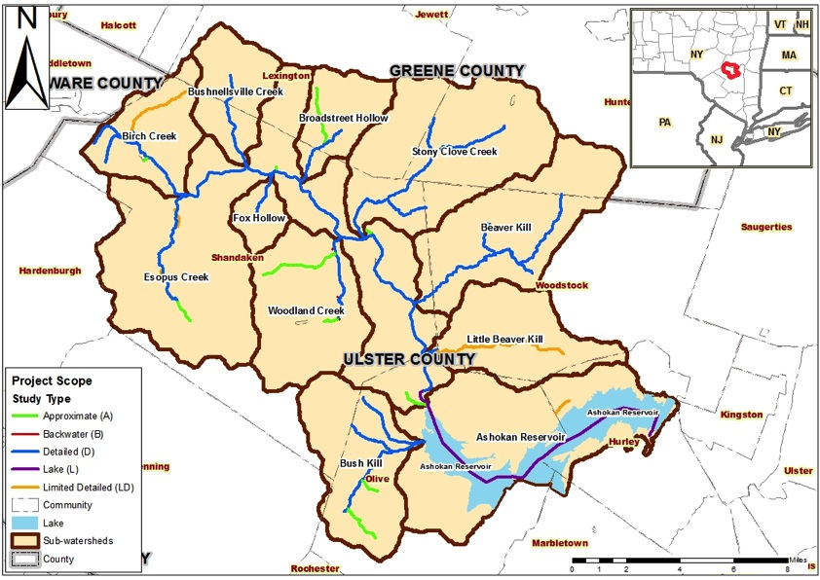
Figure 1: Esopus Watershed boundary with scoped flooding sources and labeled sub-watersheds.
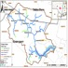
Figure 2: Esopus Watershed boundary and scoped flooding sources with Esopus Creek and major tributaries labeled.

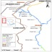
Figure 3: Scoped Flooding Sources – Part1

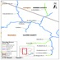
Figure 4: Scoped Flooding Sources – Part2

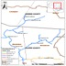
Figure 5: Scoped Flooding Sources – Part3

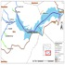
Figure 6: Scoped Flooding Sources – Part4

Study Area
The Esopus Watershed covers portions of Ulster County and Greene County in New York State. Located approximately 80 miles north of New York City (NYC), the Esopus Watershed is entirely contained within the Catskill Forest Preserve which is a part of the Catskill Mountains. The Esopus Watershed is also part of the larger Catskill Watershed, which is one of the three watersheds that supply water to NYC. The other two watersheds that supply water to NYC are the Delaware Watershed and Croton Watershed (see Figure 7). A key component of the Catskill Watershed is the Ashokan Reservoir, which is also within the Esopus Watershed. The drainage network of the Esopus Watershed includes a number of streams, with Esopus Creek being the main stream supplying the reservoir. The Catskill Aqueduct transports water collected in the Ashokan Reservoir from throughout the Esopus Watershed to the Kensico Reservoir in the Croton Watershed, which is outside the scope of the current study. The Kensico Reservoir is much closer to NYC and can provide water for immediate use. The Catskill Watershed satisfies approximately 40% of the NYC’s water supply demand (NYCDEP, 2007).
The Esopus Watershed is located in the United States Geological Survey (USGS) 8-digit hydrologic unit code (HUC8), 02020006. The total drainage area of the Esopus Watershed is approximately 255 square miles. Esopus Creek and its tributaries combine to approximately 330 miles of streams (NYCDEP, 2007). Some of the major tributaries to Esopus Creek include Birch Creek, Bushnellsville Creek, Stony Clove Creek, Fox Hollow, Broadstreet Hollow, Woodland Creek, Beaver Kill, Little Beaver Kill, and Bush Kill. The major tributaries will be treated and discussed throughout this report as sub-watersheds of the overall Esopus Watershed. Minor tributaries include Esopus Creek_t7, Traver Hollow, Hatchery Hollow, McKinley Hollow, Lost Cove, and Peck Hollow. The watershed spans across two counties, Ulster and Greene, with the majority of the area in Ulster County. The portion of the watershed in Ulster County accounts for about 82% of the total watershed area.
Esopus Creek is subject to inter-basin flow due to diversion of flows from Schoharie Reservoir to Esopus Creek. The Shandaken Tunnel, an 18-mile aqueduct built between Schoharie Reservoir and its outfall into Esopus Creek, facilitates the inter-basin transfer. The tunnel’s outfall is located just above the confluence of Esopus Creek and Broadstreet Hollow. According to NYCDEP’s stream management study, the maximum capacity of the Shandaken Tunnel (about 960 cfs) would only increase the 10%-annual chance flood elevations downstream by 2-3 inches (NYCDEP, 2007). Based on these findings, it was assumed that the maximum flow from the tunnel would not significantly increase the flood elevations of the 1%- and 0.2%-annual chance flood elevations. Therefore, the Shandaken Tunnel’s flow was not reflected in the hydrologic or hydraulic analyses of the current study. The Ashokan Reservoir is located at the downstream portion of the study area.
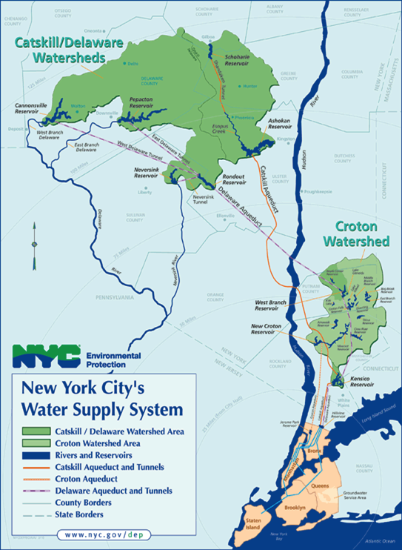
Figure 7: New York City Water Supply System (Source: NYCDEP, 2011).

Beaver Kill Watershed Study Reaches
The Beaver Kill Watershed is a sub-watershed of the Esopus Watershed and includes three streams: Beaver Kill and its two main tributaries, Wagner Creek and Mink Hollow Stream. Each was studied by detailed methods for the current study. Together, approximately 11.8 miles of stream reaches were studied within the Beaver Kill Watershed.
Beaver Kill originates in the Catskill Mountains just west of Copper Lake and the hamlet of Bearsville, Town of Woodstock, Ulster County, NY and runs primarily west until it drains into Esopus Creek at the hamlet of Mt. Tremper, Town of Shandaken, Ulster County, NY. The entire length of the study reach, from the headwaters just west of Cooper Lake to the confluence with Esopus Creek (about 6.4 miles), was studied using detailed hydraulic methods. A total of nine structures are located along Beaver Kill; seven bridges and two culverts.
Additionally, two tributaries of Beaver Kill were studied; Wagner Creek and Mink Hollow Stream. The entireties of both tributaries were also studied using detailed hydraulic methods. The Wagner Creek study reach was approximately 1.7 miles, containing two bridges and two culverts, while the Mink Hollow Stream study reach was approximately 3.6 miles, containing six bridges and one inline structure. Wagner Creek runs southeast from the mountains above to the hamlet of Willow, Town of Woodstock, Ulster County, NY, where it drains into Beaver Kill. Mink Hollow Stream runs southeast from its origin in the Catskill Mountains to the north of Cooper Lake until it drains into Beaver Kill.

Birch Creek Watershed Study Reaches
The Birch Creek Watershed is a sub-watershed of the Esopus Watershed and includes Birch Creek, Alton Creek, Alton Creek Tributary and Giggle Hollow. Birch Creek flows southwest along a narrow valley, through the hamlet of Pine Hill, town of Shandaken, Ulster County, NY, until it finally drains into Esopus Creek, near the hamlet of Big Indian, town of Shandaken, Ulster County, NY. Approximately 3.4 miles of Birch Creek was analyzed for the current study. It was analyzed in three segments (s1, s2 and s3). Reaches s1 and s2 were studied by detailed methods, and reach s3 was studied by limited detail methods. Pine Hill Lake divides reaches s1 and s2. The lake is currently offline and was not included as a part of the study. Reaches s1 and s2 were modeled as a single geometry. The detailed study limit begins at the confluence of Esopus Creek to approximately 2300ft upstream of Route 28 and includes 12 structures and an in-line weir.
Alton Creek originates in the Catskill Mountains and flows northeast until it drains into Birch Creek. It was studied by detailed methods for a length of 2.0 miles from the confluence of Birch Creek and includes 13 structures. Alton Creek Tributary was studied by detailed methods for a length of 1.6 miles from the confluence of Alton Creek and includes 8 structures and an inline-weir. At the upstream end of this reach, the limit of detail study was shifted approximately 300 feet downstream of what was originally scoped because the left overbank elevations taken from the terrain were lower than the channel elevations from the surveyed cross-section at the upstream study limit. Therefore an approximate model has been developed for this segment and mapped as Zone A. Giggle hollow was studied by approximate methods for a length of 0.2 miles from the confluence of Birch Creek.

Broadstreet Hollow Watershed Study Reaches
The Broadstreet Hollow Watershed is a sub-watershed of the Esopus Watershed and includes Broadstreet Hollow and Jay Hand Hollow. Broadstreet Hollow originates in the Catskill Mountains near the southern edge of the Town of Lexington and the border of Greene County and Ulster County, NY. It flows southwest through a narrow valley, through a portion of the town of Shandaken in Ulster County, and eventually ends at its confluence with Esopus Creek. Broadstreet Hollow was studied for a length of 3.0 miles. The upstream limit of study was at a point approximately 3200 feet upstream of the last crossing of Broadstreet Hollow Rd. The downstream study limit was at the confluence with Esopus creek. There were 10 bridges along the study reach.
Jay Hand Hollow is a tributary to Broadstreet Hollow. It also originates in the Catskills, and flows south, close to the southern edge of the Town of Lexington, Greene County, NY, until it reaches its confluence with Broadstreet Hollow. Jay Hand Hollow was studied for a length of 2.4 miles and did not contain any structures.

Bush Kill Watershed Study Reaches
The Bush Kill Watershed is a sub-watershed of the Esopus Watershed and includes Bush Kill, Maltby Hollow Brook, Dry Brook, Kanape Brook, and South Hollow Brook. The Bush Kill headwaters originate in the Catskill Mountains above the Town of Olive, Ulster County, NY. It flows northeast through the Town of Olive before it drains into the Ashokan Reservoir. Bush Kill was studied for a length of 4.7 miles. The upstream limit of study was at a point approximately 1200 feet upstream of the confluence with South Hollow Brook. The downstream study limit was at the confluence with Ashokan Reservoir. There were eight structures along the study reach.
Maltby Hollow Brook and Dry Brook are tributaries to Bush Kill that were also studied by detailed methods. They also originate in the Catskill Mountains, but flow southeast until they reach the confluence with Bush Kill. Maltby Hollow Brook and Dry Brook meet Bush Kill just upstream and just downstream of the Town of Olive, respectively. Maltby Hollow Brook was studied for a length of 2.1 miles and Dry Brook was studied for a length of 3.2 miles, containing three structures each.
Kanape Brook and South Hollow Brook are also tributaries to Bush Kill but were studied using approximate methods. They also originate in the Catskill Mountains, but flow northwest until they reach the confluence with Bush Kill. Kanape Brook is studied for a length of 1.9 miles and South Hollow Brook is studied for a length of 0.9 miles and neither contained any structures.

Bushnellsville Creek
The Bushnellsville Creek originates in the Catskill Mountains in Greene County, NY, and flows south through the hamlet of Bushnellsville, Town of Shandaken, Ulster County, NY, until it drains into Esopus Creek. Bushnellsville Creek was studied for a length of 4.0 miles. The upstream limit of study was at a point approximately 1900 feet upstream of the intersection of Highway 42 and Shaft Road. The downstream study limit was at its confluence with Esopus creek. Fifteen bridges were located along the study reach.

Esopus Creek and minor tributaries
Esopus Creek originates at Winnisook Lake on Slide Mountain within the Catskill Mountain Range. It begins running north, but curves in a clockwise direction until it settles on a southeast flow direction. It is the main stem of the Esopus Watershed. It runs for approximately 23 miles before draining into the Ashokan Reservoir. The most upstream reach, approximately 1.1 miles, was studied by approximate methods. The remaining 22 miles was studied by detailed methods.
Traver Hollow is an approximate study reach that runs approximately 1.1 miles east until it drains into Esopus Creek right at the mouth of Esopus Creek and the Ashokan Reservoir. This stream reach did not contain any structures.
Additionally, five small tributaries of Esopus Creek were included in the current study: Hatchery Hollow, McKinley Hollow, Lost Clove, Peck Hollow, and Esopus Creek_t7. Each of these stream reaches were under a mile in length. Peck Hollow did not contain any structures. Each of the other stream reaches contained a single bridge. Limited detail survey data was used to model the bridges on Hatchery Hollow and McKinley Hollow. The bridge on Lost Clove, however, was modeled as an inline structures because survey data was unavailable.

Fox Hollow
The Fox Hollow headwaters originate in the Catskill Mountains, within the Town of Shandaken, Ulster County, NY. It flows north until it converges with Esopus Creek approximately 2000 ft upstream of the hamlet of Allaben. Fox Hollow was studied for a length of 2.0 miles using detailed methods. The upstream limit of study was approximately 1000 feet upstream of the last crossing of Fox Hollow Road. The downstream limit of study was at its confluence with Esopus Creek. Seven bridges were located on the study reach.

Little Beaver Kill
Little Beaver Kill originates at Yankeetown Pond within the Town of Woodstock, Ulster County, NY. It flows west across the border of the Towns of Woodstock and Shandaken in Ulster County, until it drains into Esopus Creek. Little Beaver Kill was studied for a length of 6.3 miles. Detailed methods were used for 0.6 miles and limited detail methods were used for 5.7 miles. The upstream limit of study was Yankeetown Pond and the downstream limit was at its confluence with Esopus Creek. Little Beaver Kill was analyzed for the current study using limited detail methods within the town of Woodstock, and detailed methods within the town of Shandaken. One bridge was located on the detailed reach and 4 bridges on the limited detail reach. One inline structure was also located on the limited detail reach.

Stony Clove Creek Watershed Study Reaches
The Stony Clove Creek Watershed is a sub-watershed of the Esopus Watershed and includes three streams: Stony Clove Creek and two of its tributaries, Hollow Tree Brook and Warner Creek. Approximately, 12.0 miles of stream reaches were included in the study of the Stony Clove Creek Watershed, along with 33 structures.
Stony Clove Creek originates in the Catskill Mountains above the hamlet of Edgewood, Town of Hunter, Greene County, NY and runs primarily southwest until it drains into Esopus Creek just south of the hamlet of Phoenicia, Town of Shandaken, Ulster County, NY. The length of the stream, from the headwaters above Edgewood to the confluence with Esopus Creek (about 8.6 miles), was studied using detailed hydraulic methods. The study was divided into two reaches, one for the upstream portion of Stony Clove Creek within Greene County, and the other for the downstream portion within Ulster County. A total of nineteen bridges are located along Stony Clove Creek, thirteen in Greene County and six in Ulster County. For the Greene County portion of Stony Clove Creek, an existing model developed previously by Greene County was used for this analysis with updated peak flow discharges from the new hydrologic study.
Additionally, two tributaries of Stony Clove Creek were studied; Hollow Tree Brook and Warner Creek. Hollow Tree Brook runs south from the mountains above to the hamlet of Lanesville, Town of Hunter, Greene County, NY, where it drains into Stony Clove Creek. Warner Creek runs mostly east from its origin in the Catskill Mountains until it reaches the hamlet of Chichester, Town of Shandaken, Ulster County, NY, where it drains into Stony Clove Creek. Both tributaries were also studied using detailed methods. Approximately 1.5 miles of Hollow Tree Brook were studied, including four bridges and approximately 1.9 miles of Warner Creek were studied, also including four bridges.

Woodland Creek Watershed Study Reaches
The Woodland Creek Watershed is a sub-watershed of the Esopus Watershed and includes Woodland Creek, Cross Mountain Hollow, Muddy Brook, Panther Kill, and Tributary 3 to Woodland Creek. Woodland Creek is located in Woodland Valley in the Town of Shandaken, Ulster County, NY. It originates in the Catskill Mountains and drains into Esopus Creek. Approximately 4.1 miles of Woodland Creek were studied, including four bridges. Approximately 3.5 miles of the reach were studied using detailed methods, and 0.6 miles at the upstream end were studied using approximate methods.
In addition to Woodland Creek, four of its tributaries were also studied; Cross Mountain Hollow, Muddy Brook, Panther Kill, and Tributary 3 to Woodland Creek. For Cross Mountain Hollow, Muddy Brook, and Tributary 3 to Woodland Creek, backwater analyses were conducted. Each included one bridge along the study reach, and the study lengths were each approximately 0.1 miles. Panther Kill was studied using approximate methods for a length of 3.3 miles (from its headwaters in the Catskills to the confluence with Woodland Creek). Panther Kill did not include any structures.

Effective Flood Insurance Studies
The current study impacts the effective flood insurance studies (FISs) of Greene and Ulster counties, NY, and the towns of Hurley, Olive, Shandaken, and Woodstock, Ulster County, NY. Greene County already has an effective countywide FIS from 2008. Therefore, the impacts of this study on the towns of Hunter and Lexington, the two communities in Greene County across which some of the study reaches flow, will be incorporated into the next countywide FIS for Greene County. Ulster County, however, only has a partial countywide FIS, known as Phase 1, which only includes the geographic areas of Ulster County that lie outside the New York City Water Supply System. The streams considered in this study are all within the New York City Water Supply Watershed. Therefore, the effective FISs covering the portions of Ulster County analyzed in the current study are those of the individual towns mentioned above. This information, along with the date of each FIS, is reported in Table 4.
Table 4: Effective FISs that will be impacted by the current study, along with the effective dates.
County | Community | FIS Date
Greene | Countywide | May 16, 2008
Ulster | Town of Hurley | August 18, 1992
Ulster | Town of Olive | May 1, 1984
Ulster | Town of Shandaken | February 17, 1989
Ulster | Town of Woodstock | September 27, 1991
Ulster | Partial Countywide (Phase 1) | September 25, 2009

Only three of the flooding sources scoped under this project, Esopus Creek, Beaver Kill, and Stony Clove Creek, were previously studied using detailed methods. The remaining flooding sources either had not been studied previously or had been studied using only approximate methods. Additionally, HEC-2 was used for all of the streams studied in the effective FISs.

Other Flood Studies
Additional floodplain studies conducted by Federal or State Agencies relating to the Esopus Watershed were not available at the time of the current study.

Flooding History
Since the last FIS updates, in the ‘80s and early ‘90s, for the Ulster County communities with the Esopus Watershed, several major storms have occurred causing considerable flooding within the area. The floods that occur in summer and fall are caused mainly by heavy rainfall produced by hurricanes and tropical storms. Floods that occur in winter or spring are primarily from snowmelt caused by rising temperatures and the mixing of rain with snow. The flood of January 19, 1996, similar to the previous winter and spring floods during the 1980s, resulted from snowpack and melting conditions. Tropical Storm Floyd caused flooding in September 1999, though it likely did not exceed the 10-year event. On April 2-3 2005, Southern New York experienced large rainfall amounts that ranged from 2 – 6 inches, causing extensive flooding in the Esopus Creek Watershed, within both Ulster and Greene Counties. The flooding caused millions of dollars worth of damage and forced thousands of residents to evacuate their homes (Suro, 2007).
The most severe storms affecting the region since the publication of the effective Flood Insurance Studies were Hurricane Irene and Tropical Storm Lee in 2011, and Hurricane Sandy in 2012.
On August 28th, 2011, Hurricane Irene made landfall in New York causing significant flooding to many counties throughout the state. A week later, on September 2nd, 2011, Tropical Storm Lee brought another foot of rain too much of the Southern Tier of New York which had hardly begun to deal with the problems caused by Hurricane Irene. Together, these storms proved to be the largest and most expensive natural disaster in the history of the state, costing an estimated $1.5 billion to New York State alone (NY Governor’s Press Office, 2012). Even before Tropical Storm Lee struck, Hurricane Irene had washed out bridges and railroads, and caused some shifting in streambeds. The highest discharge on record for Esopus Creek occurred as a result of Hurricane Irene and was recorded at the Coldbrook streamgage as 75,800 cubic feet per second (cfs). This peak discharge is significantly higher than the previous record of 65,300 cfs, which occurred in March 1980 and caused millions in damages within the region. The peak discharge records at several other gages in the basin were also exceeded by the damaging discharges caused by Hurricane Irene.
On October 30th, 2012, Hurricane Sandy struck New York and wreaked havoc on New York City and the surrounding areas. The Governor of New York, Andrew Cuomo, provided an estimate of $32 billion in damages throughout New York State, $19 billion of which was associated with New York City alone (Gormley, 2012). While the storm caused the most devastation in downstate regions, the Catskills experienced strong winds and rainfall that left thousands of residents without power and at least one motorist dead (AP, 2012). There was some flooding along localized streams but no major river flooding.
The peak flows recorded at stream gages within the Esopus Watershed during Hurricane Irene exceeded previous records significantly. Therefore, this study was initiated, in part, to incorporate updated hydrologic analysis results to reflect flows and High Water Marks (HWMs) recorded for Hurricane Irene, as well as to incorporate the changes in the physical characteristics of the streams. HWMs were collected at select locations throughout the watershed. Areas of the most significant flooding were targeted, though accessibility was at times a limitation. The majority of HWMs were collected along the main stem, Esopus Creek, and many others were near the confluence of major tributaries of Esopus Creek. All 28 HWMs collected within the Esopus Watershed were within Ulster County. The number of HWMs collected per stream is provided in Table 5. Additionally, there are six active USGS stream gages within the Esopus Watershed. Again, these are all located within Ulster County. The streamgage numbers, names, and years of peak flow record are shown in Table 6. Where available, the HWMs and USGS stream gages were utilized for the calibration of the study reach models. Details of the calibration process are discussed in the calibration section of this report.

Table 5: Number of high water marks (HWMs) collected per stream within the Esopus Watershed.
Stream | Number of HWMs
Beaver Kill | 2
Bush Kill | 1
Bushnellsville Creek | 1
Esopus Creek | 16
Kenozia Lake | 1
Maltby Hollow Brook | 1
Stony Clove Creek | 6
Total | 28

Table 6: Active USGS stream gages within the current study limits.
Station Number | Station Name
1363382 | BUSH KILL BLW MALTBY HOLLOW BK AT WEST SHOKAN, NY
1362370 | STONY CLOVE CREEK BLW OX CLOVE AT CHICHESTER, NY
1413398 | BUSH KILL NEAR ARKVILLE, NY
1362200 | ESOPUS CREEK AT ALLABEN, NY
1413408 | DRY BROOK AT ARKVILLE, NY
1362500 | ESOPUS CREEK AT COLDBROOK, NY

Discharges
The hydrologic analysis defined discharges and discharge change locations for each of the study reaches analyzed in the Esopus Watershed. A calibrated HEC-HMS model formed the basis for the peak discharges developed. This information was obtained from Table 17: Summary of Recommended Discharges (Pages 66-67) of the accompanying hydrologic report (FEMA, 2013). The number of flow change locations for each sub-watershed and stream are given in Table 7. Discharges corresponding to Hurricane Irene were also developed from the calibrated HEC-HMS model of the hydrology study to aide in the calibration of the hydraulic models. For details about the hydrologic analysis, or specific flow data, please refer directly to the hydrologic report cited above.
Table 7: Number of flow change locations for each sub-watershed and each stream.
Sub-watershed | Flow Change Locations | Stream | Flow Change Locations
Beaver Kill | 7 | Beaver Kill | 4
Beaver Kill | 7 | Mink Hollow | 2
Beaver Kill | 7 | Wagner Creek | 1
Birch Creek | 9 | Alton Creek | 2
Birch Creek | 9 | Alton Creek Tributary | 1
Birch Creek | 9 | Birch Creek | 5
Birch Creek | 9 | Giggle Hollow | 1
Broad Street Hollow | 3 | Broad Street Hollow | 2
Broad Street Hollow | 3 | Jay Hand Hollow | 1
Bush Kill | 12 | Bush Kill | 6
Bush Kill | 12 | Dry Brook | 2
Bush Kill | 12 | Kanape Brook | 1
Bush Kill | 12 | Maltby Hollow Brook | 2
Bush Kill | 12 | South Hollow | 1
Bushnellsville Creek | 3 | Bushnellsville Creek | 3
Esopus Creek | 20 | Esopus Creek | 14
Esopus Creek | 20 | Esopus Creek Tributary 7 | 1
Esopus Creek | 20 | Hatchery Hollow | 1
Esopus Creek | 20 | Lost Clove | 1
Esopus Creek | 20 | McKinley Hollow | 1
Esopus Creek | 20 | Peck Hollow | 1
Esopus Creek | 20 | Traver Hollow | 1
Fox Hollow | 2 | Fox Hollow | 2
Little Beaver Kill | 4 | Little Beaver Kill | 4
Stony Clove Creek | 11 | Hollow Tree Brook | 2
Stony Clove Creek | 11 | Stony Clove Creek | 8
Stony Clove Creek | 11 | Warner Creek | 1
Woodland Creek | 9 | Cross Mount Hollow | 1
Woodland Creek | 9 | Muddy Brook | 1
Woodland Creek | 9 | Panther Kill | 1
Woodland Creek | 9 | Woodland Creek | 5
Woodland Creek | 9 | Woodland Creek Tributary 3 | 1
Total | 80 | Total | 80

Survey and Cross Section Development
New field surveys were conducted for this study along the stream reaches studied by detailed and limited detail methods. A total of 134 structures for detailed hydraulic analysis, as well as 15 structures for limited detail hydraulic analysis, along the study reaches were surveyed. The survey followed FEMA’s Appendix M: Data Capture Standards guidelines (FEMA, 2009(a)). Additionally, a total of 455 floodplain cross sections were surveyed for the streams in this study. The surveys were conducted by T.Y.LIN INTERNATIONAL between July 5 and November 17, 2011. A summary of the survey information gathered is provided in Table 8. Survey data files, photos and sketches are included in the survey data report (FEMA, 2012).
Non-surveyed floodplain cross sections were also necessary to provide adequate representation of the streams. These cross sections were placed at representative locations, usually no greater than 500 feet apart along the stream centerline. Cross section geometries were obtained from a terrain dataset built from LiDAR data, integrating survey data to better define the stream channel where applicable. The LiDAR data was originally collected in the Spring and Fall of 2009 and was provided to the NYCDEP Bureau of Water Supply by the New York State Office of Cyber Security and Critical Infrastructure Coordination’s (CSCIC) Digital Orthophotography Program (NYCDEP, 2010). The 455 surveyed floodplain cross sections along the detailed study streams were used to interpolate the channel geometry for non-surveyed cross sections, again, integrating with the data from the terrain dataset. All cross section overbank ground elevations were obtained from the terrain dataset unless otherwise specified.
The survey did not provide surveyed floodplain cross sections for limited detail or approximate study reaches. Therefore, the development of cross section geometries for all limited detail and approximate study reaches relied on the terrain dataset.
For Fox Hollow, at station 600 in the HEC-RAS model there was a mismatch between the survey data and the LiDAR data. This could have been due to missing LiDAR data points in that area. At this cross section, survey data was used to develop the overbanks. The floodplain was manually mapped based on the 1%-annual chance flood extent in the HEC-RAS model and tied in with the upstream and downstream floodplain.
For Stony Clove Creek, the Greene County model was based upon the existing model that was used to develop the current Greene County FIS. This model included eleven bridges and two culverts, with a total of 184 cross sections. New surveys were not conducted and the cross sections remained the same as the existing model for this portion of Stony Clove Creek.
Table 8: Summary of survey information for each stream.
SUB-WATERSHED | SCOPENAME | Detailed Structures | Limited Detail Structures | Cross Sections
Ashokan Reservoir | AshokanReservoir | 0 | 0 | 0
Ashokan Reservoir | KenoziaLake | 0 | 1 | 0
Beaver Kill | BeaverKill | 9 | 0 | 31
Beaver Kill | MinkHollowStream | 5 | 0 | 17
Beaver Kill | WagnerCreek | 6 | 0 | 13
Birch Creek | AltonCreek | 12 | 0 | 23
Birch Creek | AltonCreek_t1 | 9 | 0 | 16
Birch Creek | BirchCreek_s1 | 12 | 8 | 37
Broad Street Hollow | BroadStreetHollow | 9 | 0 | 30
Bush Kill | BushKill | 8 | 0 | 26
Bush Kill | DryBrook | 4 | 0 | 16
Bush Kill | MaltbyHollowBrook | 3 | 0 | 11
Bushnellsville Creek | BushnellsvilleCreek | 15 | 0 | 47
Bushnellsville Creek | BushnellsvilleCreek | 0 | 0 | 0
Esopus Creek | EsopusCreek | 15 | 0 | 78
Esopus Creek | McKinleyHollow | 0 | 1 | 0
Esopus Creek | HatcheryHollow | 0 | 1 | 0
Fox Hollow | FoxHollow | 7 | 0 | 23
Little Beaver Kill | LittleBeaverKill | 1 | 4 | 7
Stony Clove Creek | HollowTreeBrook | 4 | 0 | 11
Stony Clove Creek | StonyCloveCreek | 5 | 0 | 31
Stony Clove Creek | WarnerCreek | 4 | 0 | 13
Woodland Creek | CrossMountainHollow | 1 | 0 | 3
Woodland Creek | MuddyBrook | 1 | 0 | 4
Woodland Creek | WoodlandCreek_s1 | 4 | 0 | 21
Woodland Creek | WoodlandCreek_t3 | 1 | 0 | 3

Boundary conditions and Tie-ins
All of the study reaches in the current study were analyzed using steady state HEC-RAS models, which require downstream boundary conditions. Where water surface elevations (WSELs) at the downstream boundary of a study reach were known, they were utilized. Generally this was only the case for continuous segments of the same stream. WSELs are usually unknown for the downstream boundary of tributaries, in which case, the slope of the last two cross sections can be used to calculate the normal depth. This normal depth is then used as the downstream WSEL, or boundary condition. This is known as the normal depth method. If, however, a tributary shares a coincident peak discharge with the receiving stream, then the known WSEL of the receiving stream at the confluence must be used. Occurrence of coincident peak was determined by comparing drainage areas, times of concentration, and runoff hydrographs for all study streams. Only one occurrence of coincident peaks was found at the confluence of Bush Kill and Maltby Hollow Brook, within the Bush Kill Watershed.

Broadstreet Hollow Watershed Study Reaches
The downstream starting WSELs for all profiles of the HEC-RAS models of Broadstreet Hollow and its tributaries were calculated using the normal depth method. In the scope for the current study, Broadstreet Hollow was split into two separate reaches, one for Ulster County and one for Greene County. However, because they were both detailed study reaches and they are continuous, a single model was used for the full three miles of Broadstreet Hollow included in the scope. Therefore, a tie-in was unnecessary between the two reaches.

Bush Kill Watershed Study Reaches
The downstream starting WSELs for all profiles of the HEC-RAS models of Bush Kill and its tributaries were calculated using the normal depth method, with the exception of Maltby Hollow Brook. Maltby Hollow Brook and Bush Kill were determined to experience coincident peak flow conditions for the flood frequencies studied. Therefore, a rating curve at cross-section 6667 was developed from the Bush Kill model and used as the known starting WSELs at cross section 33.75 of the Maltby Hollow Brook HEC-RAS model. These WSELs applied at cross section 33.75 for the 10%-, 4%-, 2%-, 1%-, and 0.2%-annual chance flood profiles were 693.21, 695.14, 696.58, 698.18, and 700.92 ft, respectively.

Bushnellsville Creek
The downstream starting WSELs for all profiles in the Bushnellsville Creek HEC-RAS models were calculated using the normal depth method. In the scope for the current study, Bushnellsville Creek was split into two separate reaches, one for Ulster County and one for Greene County. However, for this study a single model was developed for the full four miles of Bushnellsville Creek.

Esopus Creek and minor tributaries
The downstream starting WSELs for all profiles in the HEC-RAS model of the detailed study reach of Esopus Creek, as well as for each of the minor tributaries, were calculated using the normal depth method. The upper reach of Esopus Creek that was studied by approximate methods required the use of a known WSEL from the downstream reach for the 1%-annual chance flood profile. The WSEL used as the boundary condition for the approximate reach HEC-RAS model was 1543.54 ft.

Little Beaver Kill
The downstream starting WSELs for all profiles in the HEC-RAS model of the downstream detailed study reach of Little Beaver Kill were calculated using the normal depth method. In order to maintain continuity between the two reaches, the known WSEL of the 1%-annual chance flood profile at the upstream end of the detailed study reach was utilized as the downstream boundary conditions for the limited detail reach. The WSEL used as the boundary condition for the limited detail HEC-RAS model was 697.56 ft.

Stony Clove Creek Watershed Study Reaches
The downstream starting WSELs for all profiles of the HEC-RAS models of Stony Clove Creek and its tributaries were calculated using the normal depth method with the exception of the Greene County portion of Stony Clove Creek. In order to maintain continuity between the Ulster and Greene County reaches of Stony Clove Creek, known WSELs for each profile at the upstream end of the Ulster County model were utilized as downstream boundary conditions for the Greene County model. The WSELs used as the boundary conditions of the 10%-, 4%-, 2%-, 1%-, and 0.2%-annual chance flood profiles for the Greene County reach HEC-RAS model were 1163.7, 1165.31, 1166.16, 1166.87, and 1170.23 ft, respectively.

Woodland Creek Watershed Study Reaches
The downstream starting WSELs for all profiles of the HEC-RAS models of Woodland Creek and its tributaries were calculated using the normal depth method with the exception of the approximate study reach of Woodland Creek. In order to maintain continuity between the two reaches, the known WSEL of the 1%-annual chance flood profile at the upstream end of the detailed study reach of Woodland Creek was utilized as the downstream boundary condition for the approximate study reach of Woodland Creek. The WSEL used as the boundary condition for the approximate study reach HEC-RAS model was 1190.95 ft.

Structures
All structures along the detailed and limited detail study reaches were field surveyed with the exception of those along the Greene County portion of Stony Clove Creek, which were taken from the existing HEC-RAS model. Structures along the approximate study reaches were generally treated as inline structures with the deck elevations defined by the LiDAR data. In cases along approximate study reaches where the structure opening was very large, treating it as an inline structure provided unreasonable results. In these cases, low flow conditions were assumed to exist and the structure was modeled using natural stream channel cross sections. Table 9 provides the number of structures of each type included in the model for each stream. None of the study streams included hydraulic structures designed to divert flow; however, a few streams did require overland flow analyses, which are described section XII. According to the guidance provided in the HEC-RAS User’s Manual, the contraction and expansion coefficients were increased to 0.3 and 0.5 at each structure’s upstream and downstream face sections and at the approach section (USACE, 2010(a)). All other contraction and expansion values were kept at 0.1 and 0.3, respectively.
It should be noted that the Grubman Rd bridge at RS 20255 of the Ulster County HEC-RAS model of Stony Clove Creek was partially washed out during Hurricane Irene, leaving only one span of the bridge over the high-flow section of the channel still standing. The span over the main channel no longer exists. This bridge was modeled as observed during the survey, only partially spanning the channel.
Table 9: Number of structures of each type modeled for each stream.
Sub-Watershed | Stream Name | Structures | Bridges | Culverts | Inline Structures
Beaver Kill | BeaverKill | 9 | 7 | 2 | 0
Beaver Kill | MinkHollowStream | 7 | 6 | 0 | 1
Beaver Kill | WagnerCreek | 4 | 2 | 2 | 0
Birch Creek | AltonCreek | 13 | 9 | 4 | 0
Birch Creek | AltonCreek_t1 | 9 | 1 | 7 | 1
Birch Creek | BirchCreek_s1s2 | 11 | 7 | 3 | 1
Birch Creek | BirchCreek_s3 | 8 | 4 | 3 | 1
Birch Creek | GiggleHollow | 0 | 0 | 0 | 0
Broad Street Hollow | BroadStreetHollow | 10 | 10 | 0 | 0
Broad Street Hollow | JayHandHollow | 0 | 0 | 0 | 0
Bush Kill | BushKill | 8 | 7 | 1 | 0
Bush Kill | DryBrook | 3 | 2 | 1 | 0
Bush Kill | KanapeBrook | 0 | 0 | 0 | 0
Bush Kill | MaltbyHollowBrook | 3 | 3 | 0 | 0
Bush Kill | SouthHollowBrook | 0 | 0 | 0 | 0
Bushnellsville Creek | BushnellsvilleCreek | 15 | 15 | 0 | 0
Esopus Creek and minor tributaries | EsopusCreek | 19 | 19 | 0 | 0
Esopus Creek and minor tributaries | EsopusCreek_zoneA | 0 | 0 | 0 | 0
Esopus Creek and minor tributaries | EsopusCreek_t7 | 1 | 0 | 0 | 1
Esopus Creek and minor tributaries | TraverHollow | 0 | 0 | 0 | 0
Esopus Creek and minor tributaries | McKinley Hollow | 1 | 0 | 1 | 0
Esopus Creek and minor tributaries | Lost Clove | 0 | 0 | 0 | 0
Esopus Creek and minor tributaries | Hatchery Clove | 1 | 1 | 0 | 0
Esopus Creek and minor tributaries | PeckHollow | 0 | 0 | 0 | 0
Fox Hollow | FoxHollow | 7 | 7 | 0 | 0
Little Beaver Kill | LittleBeaverKill | 5 | 1 | 3 | 1
Stony Clove Creek | HollowTreeBrook | 4 | 4 | 0 | 0
Stony Clove Creek | StonyCloveCreek | 13 | 11 | 2 | 0
Stony Clove Creek | StonyCloveCreek | 6 | 6 | 0 | 0
Stony Clove Creek | WarnerCreek | 4 | 4 | 0 | 0
Woodland Creek | CrossMountainHollow | 1 | 1 | 0 | 0
Woodland Creek | MuddyBrook | 1 | 1 | 0 | 0
Woodland Creek | PantherKill | 0 | 0 | 0 | 0
Woodland Creek | WoodlandCreek_s1 | 4 | 4 | 0 | 0
Woodland Creek | WoodlandCreek_s2 | 0 | 0 | 0 | 0
Woodland Creek | WoodlandCreek_t3 | 1 | 1 | 0 | 0

Ineffective and Storage Areas
Ineffective areas were used in the detailed, limited detail, and approximate study reaches to reflect areas of storage and low conveyance. In general, floodplain areas outside of the main flow path were designated as ineffective areas. Forty five degree contraction and twenty degree expansion criteria were used to model the impact of large obstructions within the floodplain or low conveyance due to floodplain shape.

Channel and Overbank Roughness Values
Manning’s n-values bear a significant impact on the results of any hydraulic model. Therefore, as much information as possible should be utilized when estimating n-values, particularly channel n-values. Channel n-values for all detailed study reaches within the Esopus Watershed were determined by analyzing field survey photographs of all surveyed cross sections. Based on the survey photographs, the Cowan method was used to compute the channel n-value at each surveyed cross section (Chow, 1959). These calculated channel n-values were then interpolated and applied to the non-surveyed cross sections. Adjustments were made to interpolated n-values as needed, using guidelines from USGS Water-Supply Paper 2441, Estimation of roughness coefficients for natural stream channels with vegetated banks. Channel n-values for limited detail studies were estimated based on aerial imagery and any available field survey photographs. For approximate study reaches, aerial imagery was mostly relied upon in estimating channel n-values. The channel n-values used for the same stream in the effective FIS and the n-values used in surrounding streams were also considered.
Generally, somewhat less information is available for estimating overbank n-values. Aerial imagery was usually the primary source of information for estimating overbank n-values, particularly for wide floodplain cross sections, because survey photographs do not provide an adequate representation of the entire overbank area. Therefore, based on the aerial imagery, a GIS land use layer was digitized to assign overbank n-values. This method was used to estimate overbank n-values for all types of study reaches.
The areas that the Esopus Watershed streams travel through are generally sparsely developed, relatively steep and rocky, and heavily forested. The channel n-values were all between 0.025 and 0.083. The highest n-values on the overbanks, between 0.080-0.120, were generally reserved for forested areas, while more scattered trees, brush, or developed areas with significant obstructions due to buildings were generally assigned somewhat lower values. Some areas of bare earth or short grass exist and were typically assigned values between 0.050 and 0.070. Where roads and other paved surfaces were included, they were generally assigned an n-value of 0.016. The differences in these assigned n-values from stream to stream are a result of slight differences in the terrain and engineering judgment. Occasionally minor adjustments were made to the initial estimations of both the channel and overbank n-values for calibration purposes. Table 10 provides a summary of the channel and overbank n-values for each of the sub-watersheds within the study.
Table 10: Summary of channel and overbank n-values for each sub-watershed in the Esopus Watershed.
Sub-watersheds | Channel n-value, Range | Overbank n-value, Range
Beaver Kill Watershed | 0.040-0.068 | 0.016-0.110
Birch Creek Watershed | 0.040-0.065 | 0.013-0.120
Broadstreet Hollow Watershed | 0.044-0.070 | 0.016-0.100
Bush Kill Watershed | 0.050-0.080 | 0.016-0.100
Bushnellsville Creek | 0.050-0.070 | 0.016-0.120
Esopus Creek and minor tributaries | 0.030-0.058 | 0.016-0.120
Fox Hollow | 0.045-0.065 | 0.016-0.100
Little Beaver Kill | 0.048-0.065 | 0.016-0.100
Stony Clove Creek Watershed | 0.025-0.083 | 0.016-0.120
Woodland Creek Watershed | 0.049-0.073 | 0.016-0.100

Split Flow/Diverted Flow Modeling
Split flow or diverted flow modeling is at times necessary when a significant amount of flow leaves the defined flow path of a stream to create an alternate channel or overland sheet flow. In either case, due to the limitations of one-dimensional HEC-RAS modeling, a mechanism was needed to model such scenarios. Therefore, the HEC-RAS lateral weir feature was used to determine the amount of flow leaving the main floodplain. Once the volume of flow was determined, then the overland flow was modeled separately.
Overland flow analysis was required for two reaches within this study; McKinley Hollow, a minor tributary of Esopus Creek; and Muddy Brook, a tributary of Woodland Creek. Each of these scenarios will be discussed individually below.

Esopus Creek and minor tributaries
McKinley Hollow is one of the minor tributaries of Esopus Creek and required overland flow analysis. On this stream, approximately 100 ft upstream of McKinley Hollow Road, sheet flow occurs on the right overbank and into Esopus Creek. The overland flow volume was computed using a lateral weir along the right overbank. This lateral weir flow was used to model and map the sheet flow along the right overbank using an approximate hydraulic analysis. Elevations for the lateral weir were obtained from the terrain dataset. Overland flow was not considered in the computation of the 1%- and 0.2%-annual chance floodplains or floodway for the main channel of McKinley Hollow.

Woodland Creek Watershed Study Reaches
For Muddy Brook, overland flow occurs immediately upstream of Wood Valley Road for the 1%- and 0.2%-annual chance flood events. An overland flow path exists on the left overbank and follows a drainage ditch adjacent to Wood Valley Road. The overland flow joins Woodland Creek at a location approximately 260 feet downstream of Muddy Brook’s confluence. Overland flow discharges were computed based on rating curves developed for Muddy Brook and the overland flow at the location of the split. The computed overland flow discharges at the downstream confluence with Woodland Creek for the 1%- and 0.2%-annual chance profiles were 210 and 800 cfs, respectively. An approximate (Zone A) floodplain along the overland flow path was developed using an overland flow HEC-RAS model. The total discharge was used to develop the floodplain and floodway for the main reach of Muddy Brook.

Calibration
Calibration is the final phase of the modeling process that serves as verification that the model adequately represents the physical system. For floodplain studies, this is often accomplished by comparing the WSELs of a recent significant flood event with the results of a model simulation under the same conditions. Additionally, measured flow rates and flow depths at USGS streamgage locations can be compared to the various flow profiles of a model simulation. For the current study, the significant flood event used as the benchmark for comparison to model outputs was Hurricane Irene which occurred in August 2011. The flooding in the Esopus Watershed caused by Hurricane Irene was severe enough to wash out bridges and shift channel centerlines in some locations. The highest flood stage and peak discharge experienced during this event was recorded at several locations by USGS stream gages in the watershed. High water marks (HWMs) were also collected at several locations, detailed in FEMA’s Rapid Response –High Water Marks Report (FEMA, 2011). The high water mark elevations used in this study were obtained from Appendix B, HWM data summary, of the above mentioned report. All stream gages and high water marks were used in the calibration of the study reaches. Some study reaches did not have any calibration data available. A summary of the available calibration data the corresponding locations are provided in Table 11 and Table 12.
Table 11: USGS stream gages used for calibration.
Station Number | Station Name | Stream Name
13621955 | Birch Creek at Big Indian, NY | Birch Creek
1363382 | Bush Kill blw Maltby Hollow Bk at West Shokan, NY | Bush Kill
1362200 | Esopus Creek at Allaben, NY | Esopus Creek
1362500 | Esopus Creek at Coldbrook, NY | Esopus Creek
1362370 | Stony Clove Creek blw Ox Clove at Chichester, NY | Stony Clove Creek
*1362380 | Stony Clove Creek near Phoenicia, NY | Stony Clove Creek
1362342 | Hollow Tree Brook at Lanesville, NY | Hollow Tree Brook
13623002 | Woodland Creek above mouth at Phoenicia, NY | Woodland Creek
*Stream gage discontinued in 2006
Table 12: High Water Marks (HWMs) used for calibration.
Stream | Number of HWMs
Beaver Kill | 2
Bush Kill | 1
Bushnellsville Creek | 1
Esopus Creek | 16
Maltby Hollow Brook | 1
Stony Clove Creek | 6
Total | 27

Beaver Kill Watershed Study Reaches

The stream reaches within the Beaver Kill Watershed included in the current study did not have any calibration data available with the exception of two HWMs at the downstream end of Beaver Kill. These HWMs were recorded shortly after Hurricane Irene struck on August 28th, 2011. The two HWMs, located 125 and 230 ft upstream of the Mt. Tremper-Phoenecia bridge, were used for calibration. Stream gages are not located along any of the study reaches within the Beaver Kill Watershed.

Various attempts to calibrate the model to match the two HWMs were unsuccessful. Even after calibration efforts, the HWM located 125 ft upstream of the bridge was 4.2 ft lower than the modeled WSEL at that location and the HWM 230 ft upstream of the bridge was 3.9 ft lower than the modeled WSEL (see Table 13). It is only possible to match the HWMs under low flow conditions at the Mt. Tremper-Phoenecia bridge; however, the Hurricane Irene discharges obtained from the hydrologic study created high flow conditions in which the bridge was overtopped. Therefore, it is the backup above the bridge that caused the large difference in the modeled WSELs and the HWMs.
Also, a major factor that brings the reliability of the HWMs into question is the fact that the stream channel appears to have shifted considerably just upstream of the Mt. Tremper-Phoenecia bridge as a result of Hurricane Irene. This was evidenced by differences in the imagery and survey data. Therefore, the overbank conditions and channel geometry at this location are no longer the same as they were at the time of Hurricane Irene. While it may be true, as suggested by the HWMs, that the bridge did not overtop during Hurricane Irene, the model suggests that if the same discharges caused by Irene were to occur again under the altered conditions of the stream channel that the bridge would overtop. This would also result in flooding several feet higher just upstream of the bridge than what was experienced during Hurricane Irene.

Table 13: Comparison of Beaver Kill HWM elevations and modeled WSELs upstream of Mt. Tremper-Phoenecia bridge.
HWM ID | Distance upstream of bridge (ft) | HWM elevation (ft) | Modeled WSEL (ft) | Difference (ft)
D1_21 | 125 | 701.2 | 705.4 | -4.2
D1_20 | 230 | 701.6 | 705.5 | -3.9

Birch Creek Watershed Study Reaches
The stream reaches within the Birch Creek Watershed included in the current study did not have any calibration data available with the exception of one streamgage along Birch Creek. A rating curve was obtained for the USGS stream gage site number 013621955: Birch Creek at Big Indian, NY. The simulated WSELs were then compared to the rating curve. The comparison was made at XS 3905 of the Birch Creek model. The USGS rating curve was created only for low flows. The modeling results compared well with the stream gage under these conditions. The model provided somewhat lower WSELs, but never more than 0.5 feet different. The comparison is shown in Figure 8.

Figure 8: USGS rating curve at streamgage 013621955: Birch Creek at Big Indian, NY, and simulated WSELs for Birch Creek.

Bush Kill Watershed Study Reaches
The only calibration data available within the Bush Kill sub-watershed was a USGS stream gage located along Bush Kill just below Maltby Hollow Brook in Ulster County (USGS 01363382 Bush Kill blw Maltby Hollow Bk at West Shokan, NY). This USGS stream gage is located between XS 6117 and XS 6505. Hence the water surface elevations are interpolated between these two cross sections and compared to the USGS stage measurements.
When plotted together, the results of the HEC-RAS model compared well with the recorded peak elevations at the USGS stream gages. A comparison of the USGS stream gage stage measurements and the HEC-RAS model results is provided in Table 14 and Table 15. This data is shown in graphical form in Figure 9.
Table 14: Peak flows and corresponding WSELs recorded at Bush Kill stream gage from 2001-2011.
Table 15: Discharges and WSELs from Bush Kill HEC-RAS model.

Figure 9: Observed and modeled stream flows and corresponding WSELs at Bush Kill stream gage.

Esopus Creek and minor tributaries
There are two USGS stream gages located along Esopus Creek, listed in Table 16. Rating curve data was obtained for two USGS stream gages and compared with the simulated rating curve from the steady HEC-RAS model. At each of the USGS streamgage locations, comparison of simulated and measured rating curves match very well at low flows but were approximately 2 ft high at high flows. The major elevation difference is occurring when the flow is above the banks. This elevation difference may be due the location difference of the measured data and the streamgage. The results are shown in Figure 10 and Figure 11.
Additionally,
Table 17 lists the location and the comparison of the HWMs along Esopus Creek and the simulated WSELs. Figure 12 through Figure 17 provide imagery of the general location of the HWMs. The difference between simulated and HWM elevations ranged from -2.6 to 4.8 ft.
Table 16: USGS Gages on Esopus Creek
Gage Number | Name | HEC-RAS Cross Section Station
01362200 | ESOPUS CREEK AT ALLABEN NY | 73043
01362500 | ESOPUS CREEK AT COLDBROOK NY | 12443

Table 17: Comparison of HWM’s and simulated WSEL on Esopus Creek
HWM ID | Lat | Long | Simulated | HWM's | Difference | Figure
HWM ID | Lat | Long | (ft) | (ft) | (ft) | Figure
D1_1 | 42.007 | -74.269 | 630.3 | 630.0 | 0.3 | 4
D1_2 | 42.007 | -74.267 | 630.5 | 630.0 | 0.5 | 4
D1_3 | 42.046 | -74.279 | 697.0 | 698.0 | -1.0 | 6
D1_4 | 42.046 | -74.279 | 697.0 | 696.9 | 0.1 | 6
D1_5 | 42.045 | -74.279 | 696.3 | 696.0 | 0.3 | 6
D1_9 | 42.081 | -74.306 | 788.0 | 791.0 | -3.0 | 7
D1_10 | 42.082 | -74.306 | 790.9 | 794.1 | -3.2 | 7
D1_11 | 42.082 | -74.306 | 793.5 | 795.2 | -1.7 | 7
D1_13 | 42.117 | -74.381 | 1017.6 | 1015.5 | 2.1 | 9
D1_14 | 42.117 | -74.382 | 1018.0 | 1015.7 | 2.3 | 9
D1_17 | 42.041 | -74.279 | 694.1 | 694.9 | -0.8 | 5
D1_18 | 42.041 | -74.279 | 693.8 | 691.3 | 2.5 | 5
D1_19 | 42.040 | -74.279 | 693.4 | 692.1 | 1.3 | 5
D1_22 | 42.075 | -74.301 | 774.0 | 776.9 | -2.9 | 8
D1_23 | 42.074 | -74.301 | 773.1 | 777.2 | -4.1 | 8

Figure 10: Simulated vs. observed comparison at USGS gage 01362200 on Esopus Creek

Figure 11: Simulated vs. observed comparison at USGS gage 01362500 on Esopus Creek

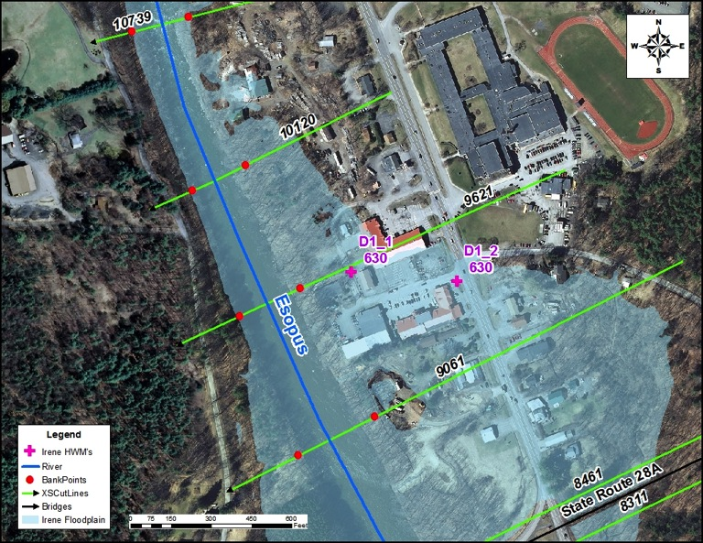
Figure 12: Location of High Water Marks D1_1 and D1_2 on Esopus Creek

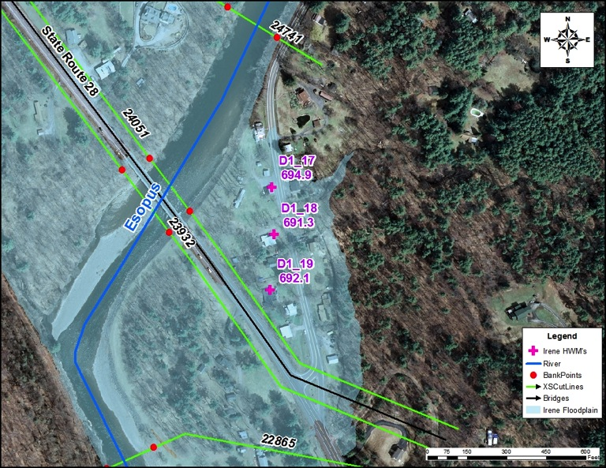
Figure 13: Location of High Water Marks D1_17, D1_18, and D1_19 on Esopus Creek

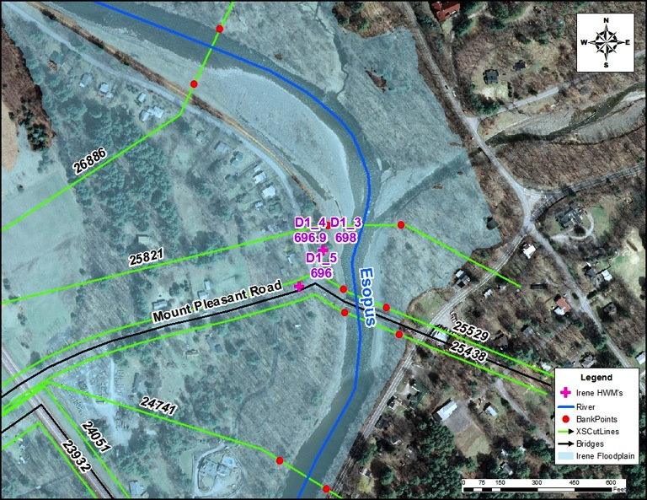
Figure 14: Location of High Water Marks D1_3, D1_4, and D1_5 on Esopus Creek

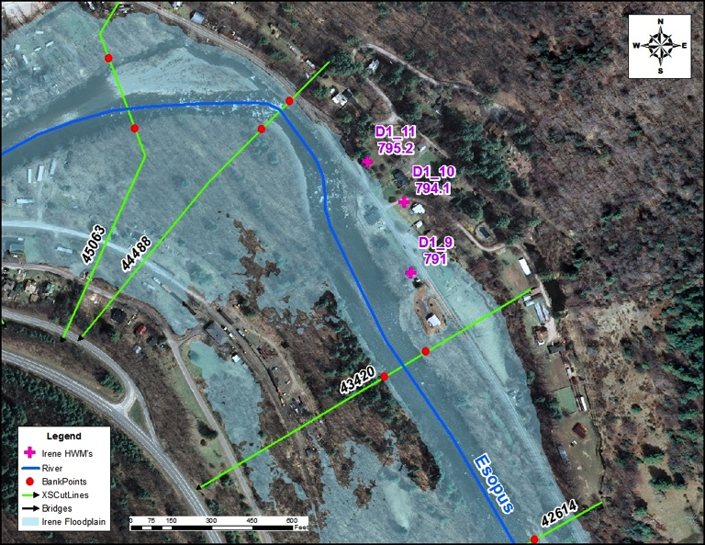
Figure 15: Location of High Water Marks D1_9, D1_10, and D1_11 on Esopus Creek

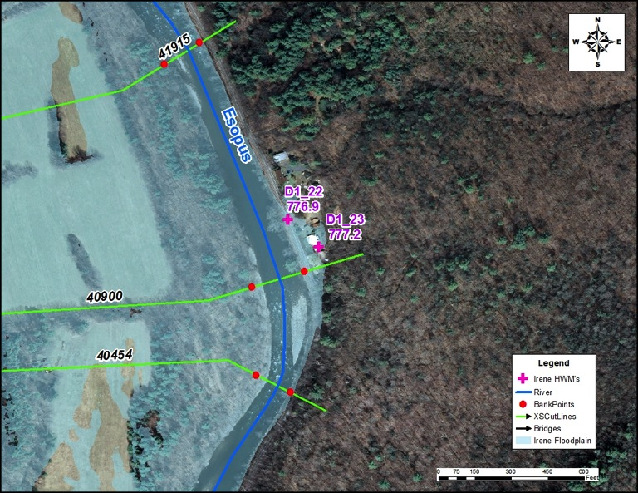
Figure 16: Location of High Water Marks D1_22 and D1_23 on Esopus Creek
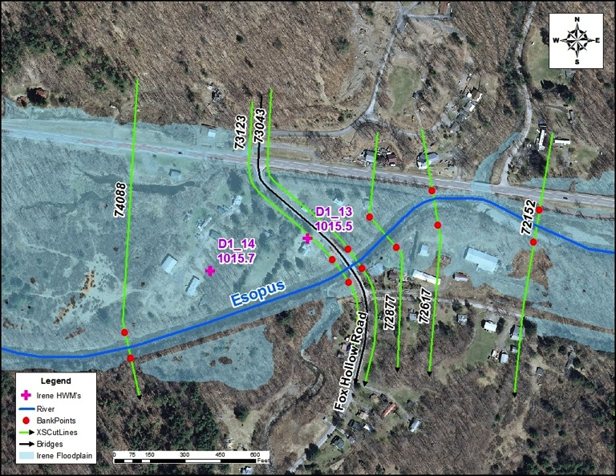
Figure 17: Location of High Water Marks D1_13 and D1_14 on Esopus Creek

Stony Clove Creek Watershed Study Reaches

Stony Clove Creek
Calibration data was not available along the Greene County reach of Stony Clove Creek. However, one active USGS streamgage is located just below the Route 214 bridge in Chichester at RS 9919 in Ulster County (USGS 01362370 Stony Clove Creek below Ox Clove at Chichester, NY). There was previously a USGS streamgage located between XS 7601 and XS 7401 (USGS 01362380 Stony Clove Creek near Phoenicia, NY) until it was put out of service in 2006. However, the records previous to 2006 were retrieved to use as a secondary rating curve. Additionally, there were six high water marks recorded from Hurricane Irene on the downstream reach of Stony Clove Creek, near the confluence of Esopus Creek. One high water mark is about 800 ft upstream of the Route 214 bridge in Phoenicia (just upstream of XS 1513), while the others are concentrated immediately around the same bridge (RS 808).
The results of the HEC-RAS model generally compared well with the recorded peak flow rates of the USGS stream gages. However, the magnitudes of the modeled flows were generally larger than the measured gage flows. A comparison of the model results and the two different USGS stream gage stage measurements are provided in Figure 18 and Figure 19. Figure 18 shows the data from the stream gage (01362370) that is still active. Figure 19 shows the data from the stream gage (01362380) that was de-activated in 2006. The model predicts somewhat higher WSELs (between 0.5 and 2.5 ft higher) than the measured values at this gage. There are several factors that could be causing these differences. One likely reason is the location of the stream gage, which is not close to a defined cross section in the model; this which makes comparison somewhat less accurate. For this reason, the de-activated streamgage was not used for calibration specifically, but rather for comparison only.

Figure 18: Comparison of USGS streamgage (Stony Clove Creek below Ox Clove at Chichester, NY) data and simulated WSELs at XS 9861.

Figure 19: Comparison of USGS streamgage (Stony Clove Creek near Phoenicia, NY) data and simulated WSELs at XS 7041.
High water marks from Hurricane Irene at the downstream end of Stony Clove Creek were also used to calibrate the model. All HWM locations (with labeled elevations) are shown in Figure 20. Initially, the model was set up using discharges and discharge change locations based upon a hydrologic model of the watershed. Discharge rates for Hurricane Irene were estimated at each flow change location with the hydrologic model. Using these inputs, the model was calibrated to match one of the HWMs located about 800 ft upstream of the Route 214 bridge in Phoenicia (100 ft upstream of XS 1513). The other HWMs surrounding the same bridge at RS 808 were not considered as important for calibration purposes because of the conditions at that location. Firstly, this location overlaps with the Esopus Creek floodplains and is susceptible to backwater effects from the Esopus Creek. This could explain why the HWM about 80 ft downstream of XS 683 is 1.5 ft higher than the high water mark about 70 ft upstream of XS 683. Secondly, overland sheet flow (2-D flow) occurs near the bridge, as was recorded during Hurricane Irene. This explains why two different HWM elevations could occur along almost the same cross section (813.7 ft and 813.2 ft, both parallel and just upstream of XS 683). It also suggests that completely accurate modeling/calibration of these conditions may not be achievable with a 1-D HEC-RAS model. For these reasons, the two HWMs just upstream of XS 683 were treated as unreliable and the HWM about 800ft upstream of the bridge, just upstream of XS 1513, was used as the principle HWM for calibration. Some other HWMs aligned well with the WSELs, but some were several feet different.
Finally, the Hurricane Irene flow recorded at the active USGS gage was applied to the downstream segment of the stream. This flow was nearly 1600 cfs larger than the Irene flow obtained from the hydrologic model simulation. The model results using the two different Irene flows compared to the HWMs are given in Table 18. In both cases the model produced water surface elevations within the tolerance of 0.5 ft for the most upstream high water mark, about 800 ft upstream of the Route 214 bridge. The WSELs also matched the HWM located about 60 ft upstream of the upstream face of the bridge for both flows within the allowable tolerance. None of the HWMs at or below the bridge matched the WSELs reasonably or reliably.
Table 18: Comparison of model results using measured and estimated flows of Hurricane Irene and downstream high water marks.
 |  | Hydrologic Model Irene flow (12709 cfs) |  | USGS stream gage Irene flow (14300 cfs)
Approximate Location | HWM Elevation (ft) | WSEL (NAVD88, ft) | Difference (ft) | WSEL (NAVD88, ft) | Difference (ft)
100ft US of XS 1513 | 828.00 | 827.86 | 0.14 | 828.20 | -0.20
60ft US of Rt 214 Bridge | 820.90 | 820.40 | 0.50 | 821.24 | -0.34
USF of Rt 214 Bridge | 822.10 | 820.21 | 1.89 | 821.06 | 1.04
DSF of Rt 214 Bridge | 822.10 | 820.21 | 1.89 | 821.06 | 1.04
70ft US of XS 683 | *813.70 | 819.30 | -5.60 | 820.02 | -6.32
40ft US of XS 683 | *813.20 | 818.80 | -5.60 | 819.52 | -6.32
80ft DS of XS 683 | 815.20 | 815.56 | -0.36 | 815.94 | -0.74
*High water marks determined to be unreliable for reasons explained above.

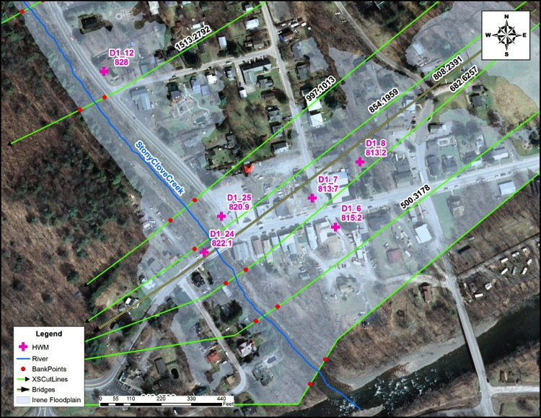
Figure 20: Location and elevation of HWMs from Hurricane Irene on Stony Clove Creek near the confluence of Esopus Creek.

Hollow Tree Brook
High water marks were not available for Hollow Tree Brook. However, USGS streamgage 01362342: Hollow Tree Brook at Lanesville, NY, is located in the upstream part of the study reach. The USGS reported stage-discharge rating data does not cover the range of peak flows estimated in the hydrology analysis for this study reach. The highest discharge of the USGS rating data is 522 cfs. The maximum discharge reported by USGS for this gage is 487 cfs (on August 28, 2011). Figure 21 below compares USGS reported data for this stream gage and results from the model at approximately the same location: the red line with the rounded markers represent the results of the model for the five peak flow frequencies included in this study; the red line with the square markers corresponds with the results of the model when it is run using the same discharges reported by the USGS stage-discharge rating data; the blue line is the USGS Stage-discharge rating data; and the black triangle markers are USGS peak stream flow data published at the USGS website for this gage.
Table 19 below presents a comparison of HEC-RAS simulated results with the flow data published by the USGS in the peak stream flow webpage for this gage. Simulated flood elevations compare well with observed elevations except for the August 28, 2011 storm Irene. USGS states that the rating curve for the Hollow Tree Brook gage for discharges higher than 230 cfs was extrapolated based on back water analysis. However, the topographic data used in the HEC-RAS model developed for this project is based on a survey conducted between August 11, 2011 and August 18, 2011. The water surface elevations predicted by the HEC-RAS model developed for this project for higher flows appear to be representative of a floodplain with overbanks. Due to the differences between the model results and the discharges and elevations published by the USGS for Irene, the HEC-RAS model for Hollow Tree Brook will be made available to the New York district of USGS once the project is completed.
Table 19: Comparison of USGS peak stream flows with model results.
USGS Peak Streamflow |  |  |  |  | Model (XS 6404.6) @ USGS Peak Streamflow | WSEL diff = Model-USGS Peak Streamflow
Date | Gage Height | Gage Stream flow | WSEL | WSEL | Model (XS 6404.6) @ USGS Peak Streamflow | WSEL diff = Model-USGS Peak Streamflow
Date | (ft) | (cfs) | (NGVD29 ft) | (NAVD88 ft) | WSEL (NAVD88 ft) | (NAVD88 ft)
4/1/2002 | 2.40 | 15.00 | 1,479.43 | 1478.84 | 1478.91 | 0.07
12/12/2008 | 2.16 | 59.00 | 1,479.19 | 1478.60 | 1479.3 | 0.70
9/28/2003 | 2.95 | 60.00 | 1,479.98 | 1479.39 | 1479.3 | -0.09
4/16/2007 | 2.31 | 83.00 | 1,479.34 | 1478.75 | 1479.43 | 0.68
6/7/2000 | 2.61 | 86.00 | 1,479.64 | 1479.05 | 1479.44 | 0.39
6/14/1998 | 2.71 | 99.00 | 1,479.74 | 1479.15 | 1479.5 | 0.35
11/20/2003 | 3.20 | 102.00 | 1,480.23 | 1479.64 | 1479.57 | -0.07
12/17/2000 | 2.77 | 107.00 | 1,479.80 | 1479.21 | 1479.54 | 0.33
3/8/2008 | 2.46 | 123.00 | 1,479.49 | 1478.90 | 1479.61 | 0.71
1/25/2010 | 3.08 | 247.00 | 1,480.11 | 1479.52 | 1480.09 | 0.57
11/30/2005 | 3.19 | 262.00 | 1,480.22 | 1479.63 | 1480.13 | 0.50
9/16/1999 | 3.69 | 263.00 | 1,480.72 | 1480.13 | 1480.14 | 0.01
4/2/2005 | 4.12 | 360.00 | 1,481.15 | 1480.56 | 1480.45 | -0.11
8/28/2011 | 5.89 | 487.00 | 1,482.92 | 1482.33 | 1480.82 | -1.51

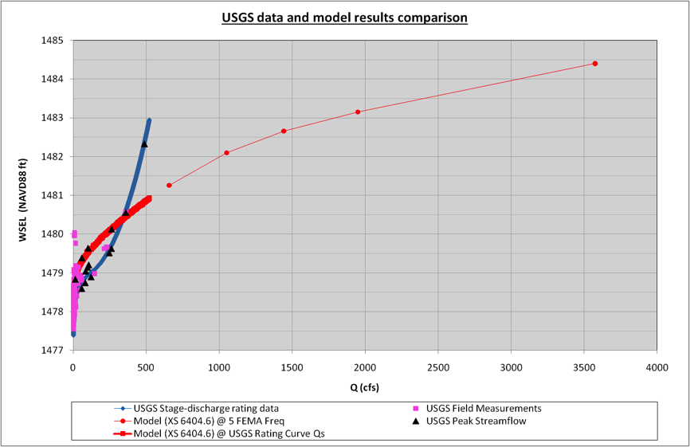
Figure 21: USGS stream gage data and model results comparison on Hollow Tree Brook.

Woodland Creek Watershed
Calibration data was not available for the Woodland Creek Watershed study reaches with the exception of one USGS streamgage located at the downstream end of Woodland Creek. This streamgage, USGS 013623002: Woodland Creek above mouth at Phoenicia, NY, was used to calibrate the Woodland Creek hydraulic model. The streamgage location corresponds to cross section 1213 in the model. However, the results of the model at this cross section did not provide WSELs that compared well with the observed WSELs from the streamgage. It was then discovered that the invert at cross section 1213 did not match the datum specified for USGS streamgage 013623002. However, the invert of the cross section immediately upstream (1524) did compare well with the published datum and the modeled WSELs at this cross section matched the observed WSELs as well. This is demonstrated in Table 20 where it is shown that only two of five discharges produced WSEL differences greater than 0.5 feet and none produced differences greater than 1.0 feet. Because the results at cross section 1524, located approximately 300 feet upstream of the reported USGS streamgage location, compared so much better and more reliably with the observed streamgage data than the results at cross section 1213, the USGS has been informed of this observation with the proposal that the longitude and latitude of the streamgage be checked and verified. Additionally, a comparison of the rating curves developed from the streamgage and from the model results is provided in Figure 22.

Table 20: USGS stream gage 013623002 observed WSELs compared with simulated WSELs at cross section 1213.
 | Stage (ft, NAVD)
Discharge (cfs) | USGS 013623002 | RAMPP Sta. 1524 | Difference (ft)
3810 | 878.79 | 878.6 | 0.19
4260 | 879.03 | 878.86 | 0.17
5810 | 878.79 | 879.68 | -0.89
6690 | 880.52 | 880.11 | 0.41
8600 | 881.79 | 880.98 | 0.81

Figure 22: Comparison of USGS 013623002 rating curve and model results at cross section 1213.

Floodway
Floodways were developed for all detailed and backwater study reaches with the Esopus Watershed. Initial floodway configuration of each stream was developed using equal conveyance reduction criterion (HEC-RAS Method 4, (USACE, 2012(b))). Necessary adjustments to the floodway stations were made manually (using HEC-RAS Method 1) to meet surcharge regulatory limits (1.00 ft) at all cross sections and ensure the final floodway was hydraulically smooth. The only effective floodways available for comparison included portions of Beaver Kill and Stony Clove Creek. Although Esopus Creek also had an effective floodway, as indicated in the floodway data table in the effective FIS, the mapping of the effective floodway was unavailable for comparison at the time of this study. The differences between the floodways developed for the current study and the effective floodways for Beaver Kill and Stony Clove Creek will be discussed individually.

Beaver Kill
The floodway for Beaver Kill (approximately 6.4 miles) developed for the current study overlaps the floodway of the effective FIS for most of the length of the study reach. The effective floodway begins approximately one mile upstream of the confluence of Beaver Kill and Esopus Creek and continues upstream to the origins of the stream just to the west of Cooper Lake. The floodway from the current study was generally wider than the effective floodway, except for the portion upstream of the Sickler Road culvert where the floodway became narrower. The floodway widened the most in the wide, flat, marshy floodplain between the confluences of Wagner Creek and Mink Hollow Stream with Beaver Kill.
The proposed floodway of the current study suggests one considerable change from the effective floodway. The effective floodway appears to follow the flow path of a small tributary for approximately 500 feet at the upstream end, while the floodway of the current study diverges and follows a different stream line for approximately 1,000 feet. The reason for the change is that the alternate stream line used in the current study was determined to have the greater drainage area and to represent the flow path of the stream more accurately.

Stony Clove Creek (Greene County)
The floodway for Stony Clove Creek within Greene County was developed based on the effective floodway. The effective floodway encroachment stations were used as the starting points using Method 1. Necessary adjustments were then made to meet the allowable regulatory criteria. The new floodway width increased at some cross section locations and decreased at others. The maximum increase of 210 ft was at STA 0.13 mile cross-section and the maximum decrease was 98 ft at STA 0.01 mile cross-section. A table providing a detailed comparison of the effective floodway with the new study is included in Appendix A.

Results
Flood elevations, floodplains, and floodways were developed for a total of approximately 76.4 miles of stream reaches with the Esopus Watershed, extending the detailed floodplain analysis coverage by approximately 51.5 miles. For all 76.4 miles of detailed study reaches, profiles for the 10%-, 4%-, 2%-, 1%-, and 0.2%-annual chance discharges were developed. A 1%- and 0.2%-annual chance floodplain, as well as a floodway, were also developed for each of these study reaches. Additionally, 1%-annual chance profiles along with 1%-annual chance floodplains were developed using limited detail methods for approximately 10.1 miles of streams, and 1%-annual chance floodplains were developed using approximate methods for approximately 12.1 miles of streams.
Three stream sections were studied by detailed methods in both the effective FIS and the current study, totaling approximately 24.9 miles of stream reaches. These include portions of Esopus Creek, Beaver Kill, and Stony Clove Creek. Overall, the newly developed floodplains and the effective floodplains for these stream segments compared well. Any significant differences will be discussed for each stream individually.
Five stream sections were studied by approximate methods in both the effective FIS and the current study, totaling approximately 4.7 miles of stream reaches. These include portions of Giggle Hollow, Kanape Brook, South Hollow Brook, Traver Hollow, and Woodland Creek. Overall, the newly developed floodplains and the effective floodplains for these stream segments compared well.
It should be noted that along several streams in this study high velocities were calculated (greater than 10 fps). Even after making reasonable adjustments to n-values these high velocities persisted in many cases. Finally, the high velocities were justified due to the steep slopes and rocky terrain along many of the study reaches.

Beaver Kill Watershed Study Reaches
Beaver Kill is the only study reach within the Beaver Kill sub-watershed that was previously studied. Therefore, only the results of the analysis of Beaver Kill could be compared with the effective FIS. This comparison showed that the 1%-annual chance floodplain developed for the current study was generally wider than the effective 1%-annual chance floodplain, with the greatest widening occurring at the already wide and flat floodplain sections. At some locations there were significant increases in the WSELs, the largest being approximately 11ft just upstream of the first bridge crossing of Route 212. However, due to the steep bank slopes and deep channel, this elevation difference only caused an approximately 50ft increase in the 1%-annual chance floodplain width. The WSEL differences are primarily due to the increase in discharge rates (approximately 150% increase at downstream end), the increased detail and accuracy in modeling structures, and the updated topography between the effective FIS from 1991 and today. A further comparison at cross sections immediately upstream of the structures along the reach is provided in Appendix A.

Esopus Creek and minor tributaries
The proposed flows for Esopus Creek decreased from the effective FIS flows. Accordingly, the WSELs for the current study decreased when compared to the effective FIS WSELs, as listed in Table 21. The proposed WSELs reduced when compared with effective FIS, by a range of 2.1 to 10.3 feet. The reduction in WSELs generally resulted in the decrease of floodplain widths; however, at a few locations the effective floodplain is wider than the proposed floodplain. This may be the result of changes in the topology and stream migration. The change in floodplain width ranges from 90 to 1110 feet.
Table 21: Comparison of proposed and effective FIS 1%-annual chance WSELs for Esopus Creek.
Town | Road |  | 100yr Water Surface Elevation |  |  | HEC-RAS Station
Town | Road | Location | Effective FIS | Proposed | Difference | HEC-RAS Station
Olive | Conrail | DS | 618 | 615.9 | -2.1 | 5909
Olive | Conrail | US | 626.5 | 622.8 | -3.7 | 5991
Olive | State Route 28 A | DS | 636 | 629.1 | -6.9 | 8311
Olive | State Route 28 A | US | 638 | 630.6 | -7.4 | 8461
Olive | Nissen Road | DS | 651 | 648.3 | -2.7 | 12443
Olive | Nissen Road | US | 657.5 | 647.2 | -10.3 | 12549
Shandaken | State Route 28 | DS | 701 | 691.7 | -9.3 | 23932
Shandaken | State Route 28 | US | 702 | 695.3 | -6.7 | 24051
Shandaken | Access Road | DS | 703 | 696.4 | -6.6 | 25438
Shandaken | Access Road | US | 704 | 697.3 | -6.7 | 25529
Shandaken | County Route 55 | DS | 811 | 808 | -3 | 45778
Shandaken | County Route 55 | US | 817.5 | 811.4 | -6.1 | 45900
Shandaken | State Route 28 | DS | 822 | 814 | -8 | 46530
Shandaken | State Route 28 | US | 826.5 | 816.9 | -9.6 | 46764
Shandaken | Woodland Valley Road | DS | 857.5 | 848.1 | -9.4 | 50661
Shandaken | Woodland Valley Road | US | 864 | 855.3 | -8.7 | 50741
Shandaken | Fox Hollow Road | DS | 1023 | 1016 | -7 | 73043
Shandaken | Fox Hollow Road | US | 1024.5 | 1019.4 | -5.1 | 73123
Shandaken | State Route 28 | DS | 1060 | 1052.3 | -7.7 | 77943
Shandaken | State Route 28 | US | 1063 | 1058.3 | -4.7 | 78084

Stony Clove Creek Watershed Study Reaches
Only the Greene County reach of Stony Clove Creek had flood elevations from a previous study to specifically compare against the results of this study. A table comparing the WSELs between the new study and effective study has been provided in Appendix A. The maximum increase in 1%-annual chance WSEL was approximately 3.4 ft and maximum decrease was approximately 5.27 ft. Most of the increases can be attributed to increased discharges and the decreases can be attributed to the decreased discharges.

References
- Associated Press (AP). 2012. Hurricane Sandy reaches Upstate New York. October 30, 2012. http://www.thestylus.net/mobile/news/hurricane-sandy-reaches-upstate-new-york-1.2940315, accessed February 2013.
- Chow, V. T. 1959. Open-Channel Hydraulics, McGraw-Hill, New York.
- Coon, W. F. 1998. Estimation of Roughness Coefficients for Natural Stream Channels with Vegetated Banks, prepared in cooperation with the New York State Department of Transportation. U.S. Geological Survey water-supply paper 2441.
- Federal Emergency Management Agency (FEMA). 2009(a). Appendix M: Data Capture Standards.
- Federal Emergency Management Agency (FEMA). 2009(b). Guidelines and Specifications for Flood Hazard Mapping Partners, Appendix C: Guidance for Riverine Flooding Analysis and Mapping.
- Federal Emergency Management Agency (FEMA). 2011. Rapid Response – New York West of Hudson Watershed Riverine High Water Marks Hurricane/Tropical Storm Irene; Contract No. HSFEHQ-11-J-0001; FEMA-DE-50000-NY, November 2011.
- Federal Emergency Management Agency (FEMA). 2012. Field Survey Technical Support Data Notebook. Task Order HSFE02-11-J-0001 for Esopus Watershed, New York. FEMA IDIQ Contract HSFEHQ-09-D-0369, August 31, 2012.
- Federal Emergency Management Agency (FEMA). 2013. Hydrologic Analysis Technical Support Data Notebook. Task Order HSFE02-10-J-0001 for Ashokan Reservoir Watershed Hydrologic Study – Watershed Model, New York. FEMA Contract No. HSFEHQ-09-D-0369.
- Gormley, Michael. 2012. Cuomo: Sandy Cost NY, NYC $32B in Damage and Loss. Associated Press, November 26, 2012. http://bigstory.ap.org/article/cuomo-bloomberg-brief-ny-delegation-storm-cost, accessed February, 2013.
- New York City Department of Environmental Protection (NYCDEP). 2007. Cornell Cooperative Extension - Ulster County, U.S. Army Engineer Research Development Center, Upper Esopus Creek Management Plan, January 2007.
- New York City Department of Environmental Protection (NYCDEP). 2010. Upgraded Geographic Information Systems Digital Orthoimagery and Lidar Data. Bureau of Water Supply, Watershed Protection and Planning, GIS Section, March 2010.
- New York Governor’s Press Office. 2012. New York State Responds, Hurricane Irene and Tropical Storm Lee: One Year Later, August 2012. http://www.governor.ny.gov/press/08232012-hurricane-irene-hurricane-lee-state-aid, accessed February 2013.
- Suro, Thomas P. and Firda, Gary D. 2007. Flood of April 2-3, 2005, Esopus Creek Basin, New York. U. S. Geological Survey Open-File Report: 2007-1036.
- U.S. Army Corps of Engineers (USACE). 2010(a). Hydrologic Engineering Center, HEC-RAS River Analysis System, User’s Manual, Version 4.1.
- U.S. Army Corps of Engineers (USACE). 2010(b). Hydrologic Engineering Center, HEC-RAS River Analysis System, Hydraulic Reference Manual, Version 4.1.

Appendix A
Effective vs. New Study Comparison Tables
Table A.1: Comparison of results between new study and effective FIS at cross sections upstream of structures for Beaver Kill
River Sta | Profile | Structure Type | Structure Name | Q Total | W.S. Elev | Effective FIS W. S. Elev | W.S. Elev Difference
 |  |  |  | (cfs) | (ft) | (ft) | (ft)
31561.5 | 100year | Culvert | Sickler Rd | 582.5 | 1076.20 | 1076.8 | -0.60
31136.2 | 100year | Culvert | Driveway #3 | 582.5 | 1075.04 | - | -
20844.3 | 100year | Bridge | Route 212 #3 | 10108.6 | 1045.95 | 1038.5 | 7.45
17748.6 | 100year | Bridge | Route 212 #2 | 10108.6 | 1005.53 | 999.8 | 5.73
13282.8 | 100year | Bridge | Ideal Park Rd | 12763.9 | 938.37 | 937.4 | 0.97
11198.0 | 100year | Bridge | Driveway #2 | 12763.9 | 914.68 | 907.1 | 7.58
9612.6 | 100year | Bridge | Driveway #1 | 12763.9 | 877.91 | 875.3 | 2.61
6387.3 | 100year | Bridge | Route 212 #1 | 12763.9 | 811.05 | 800.0 | 11.05
728.7 | 100year | Bridge | Mt. Tremper-Phoenecia Rd (Old Route 28) | 12763.9 | 706.10 | - | -

Table A.2: Comparison of results between effective and new study for Stony Clove Creek – Greene County Reach
River Station | WSEL-Restudy |  |  | WSEL-Effective |  |  |  | FW-Width |  |  | 100YR-WSEL
River Station | W/out Floodway | With Floodway | Increase | Without Floodway | With Floodway | Increase | XS Letter | Restudy | Effective FIS | Difference | Difference
(mile) | (ft) | (ft) | (ft) | (ft) | (ft) | (ft) | XS Letter | (ft) | (ft) | (ft) | (ft)
4.75246 | 1793.67 | 1794.03 | 0.36 | 1793.63 | 1793.89 | 0.26 |  | 67.45 | 79.15 | -11.7 | 0.04
4.72506 | 1793.9 | 1794.17 | 0.27 | 1793.52 | 1793.73 | 0.21 |  | 73.2 | 91.03 | -17.83 | 0.38
4.68313 | 1793.87 | 1794.14 | 0.27 | 1793.31 | 1793.46 | 0.15 |  | 91.82 | 92.98 | -1.16 | 0.56
4.67787 | 1793.84 | 1794.11 | 0.28 | 1793.28 | 1793.44 | 0.16 | O | 98.16 | 99.65 | -1.49 | 0.56
4.64155 | Culvert |  |  |  |  |  |  |  |  | 0
4.63853 | 1773.27 | 1774.07 | 0.8 | 1773.6 | 1773.68 | 0.08 |  | 23.9 | 23.9 | 0 | -0.33
4.63119 | 1771.67 | 1771.59 | -0.08 | 1771.17 | 1771.27 | 0.1 | N | 33 | 40.25 | -7.25 | 0.5
4.61913 | 1768.98 | 1769.8 | 0.82 | 1769.42 | 1769.68 | 0.26 |  | 32.62 | 57.46 | -24.84 | -0.44
4.61025 | 1769.45 | 1770.39 | 0.94 | 1769.13 | 1769.42 | 0.29 |  | 64.27 | 86.8 | -22.53 | 0.32
4.60399 BR U | 1769.45 | 1770.39 | 0.94 | 1769.13 | 1769.42 | 0.29 |  | 64.27 | 86.8 | -22.53 | 0.32
4.60399 BR D | 1768.34 | 1768.29 | -0.05 | 1767.99 | 1769.25 | 1.26 |  | 91.61 | 57 | 34.61 | 0.35
4.60229 | 1767.5 | 1768.27 | 0.76 | 1766.9 | 1767.65 | 0.75 |  | 93.98 | 57 | 36.98 | 0.6
4.60004 | 1767.45 | 1768.18 | 0.74 | 1766.95 | 1767.74 | 0.79 |  | 106.77 | 73.57 | 33.2 | 0.5
4.59222 | 1767.27 | 1768.11 | 0.84 | 1766.76 | 1767.56 | 0.8 |  | 124.48 | 90.9 | 33.58 | 0.51
4.58978 | 1766.25 | 1766.74 | 0.49 | 1766.72 | 1767.51 | 0.79 |  | 132.05 | 139.48 | -7.43 | -0.47
4.58284 BR U | 1766.25 | 1766.74 | 0.49 | 1766.72 | 1767.51 | 0.79 |  | 88.59 | 119.87 | -31.28 | -0.47
4.58284 BR D | 1762.29 | 1764.38 | 2.09 | 1761.87 | 1763.13 | 1.25 |  | 57.8 | 63.17 | -5.37 | 0.42
4.58005 | 1758.08 | 1758.08 | 0 | 1756.42 | 1756.39 | -0.02 |  | 28.36 | 25.36 | 3 | 1.66
4.57797 | 1751.31 | 1751.32 | 0.02 | 1753.24 | 1753.26 | 0.02 |  | 79.1 | 92.09 | -12.99 | -1.93
4.53859 | 1738.25 | 1738.49 | 0.24 | 1739.24 | 1739.24 | 0.01 |  | 59.01 | 73 | -13.99 | -0.99
4.50503 | 1726.95 | 1727.73 | 0.79 | 1730.92 | 1731.2 | 0.27 |  | 61.06 | 89.34 | -28.28 | -3.97
4.46974 | 1719.69 | 1719.74 | 0.05 | 1720.77 | 1721.4 | 0.63 | M | 41.34 | 61.29 | -19.95 | -1.08
4.43288 | 1709.07 | 1710.04 | 0.97 | 1714.34 | 1714.91 | 0.57 |  | 36.52 | 74.44 | -37.92 | -5.27
4.41362 | 1707.49 | 1707.72 | 0.23 | 1710.91 | 1711.4 | 0.49 |  | 59.17 | 62.07 | -2.9 | -3.42
4.39292 | 1703.09 | 1703.12 | 0.03 | 1704.51 | 1704.43 | -0.08 |  | 62.9 | 71.6 | -8.7 | -1.42
4.35406 | 1696.13 | 1696.24 | 0.11 | 1697.57 | 1697.71 | 0.14 |  | 86.81 | 106.79 | -19.98 | -1.44
4.34403 | 1693.39 | 1693.41 | 0.02 | 1694.47 | 1694.58 | 0.11 |  | 76.56 | 97 | -20.44 | -1.08
4.32917 | 1691.19 | 1691.72 | 0.52 | 1690.49 | 1690.46 | -0.03 |  | 64.66 | 86.28 | -21.62 | 0.7
4.30676 | 1684.97 | 1685.82 | 0.85 | 1688.13 | 1688.57 | 0.43 |  | 47.46 | 104.78 | -57.32 | -3.16
4.26858 | 1683.84 | 1683.93 | 0.1 | 1685.7 | 1685.9 | 0.21 |  | 94.75 | 89.24 | 5.51 | -1.86
4.23024 | 1678.88 | 1679.35 | 0.47 | 1680.67 | 1681.32 | 0.65 |  | 81.17 | 94.34 | -13.17 | -1.79
4.19149 | 1673.04 | 1673.49 | 0.45 | 1674.84 | 1675.29 | 0.45 |  | 75.38 | 72.85 | 2.53 | -1.8
4.14285 | 1667.02 | 1667.14 | 0.12 | 1668.4 | 1668.72 | 0.32 |  | 119.03 | 118.32 | 0.71 | -1.38
4.13227 | 1665.72 | 1665.8 | 0.08 | 1667.28 | 1667.39 | 0.1 |  | 126.95 | 123.77 | 3.18 | -1.56
4.1136 | 1660.83 | 1660.83 | 0 | 1662.1 | 1662.15 | 0.05 | L | 77.15 | 91.31 | -14.16 | -1.27
4.07684 | 1644.91 | 1645.26 | 0.34 | 1648.25 | 1648.67 | 0.42 |  | 49.79 | 96.44 | -46.65 | -3.34
4.02823 | 1636.9 | 1636.94 | 0.04 | 1638.32 | 1638.26 | -0.06 |  | 71.48 | 92 | -20.52 | -1.42
3.99402 | 1627.51 | 1628.45 | 0.95 | 1629.93 | 1630.18 | 0.25 |  | 50.7 | 99.62 | -48.92 | -2.42
3.95594 | 1620.8 | 1621.39 | 0.59 | 1623.93 | 1624.1 | 0.17 |  | 63.58 | 73.68 | -10.1 | -3.13
3.91617 | 1616 | 1616.06 | 0.06 | 1619.6 | 1619.74 | 0.13 |  | 58.22 | 113.77 | -55.55 | -3.6
3.87555 | 1609.8 | 1610.04 | 0.25 | 1612.61 | 1613.25 | 0.64 | K | 54.96 | 66.17 | -11.21 | -2.81
3.84427 | 1606.46 | 1607.14 | 0.69 | 1608.14 | 1608.48 | 0.34 |  | 73.05 | 84.43 | -11.38 | -1.68
3.83743 | 1606.13 | 1606.87 | 0.74 | 1607.49 | 1607.9 | 0.42 |  | 72.77 | 119.21 | -46.44 | -1.36
3.83274 BR U | 1606.13 | 1606.87 | 0.74 | 1607.49 | 1607.9 | 0.42 |  | 72.77 | 119.21 | -46.44 | -1.36
3.83274 BR D | 1605.75 | 1606.1 | 0.35 | 1606.66 | 1606.79 | 0.13 |  | 75.73 | 119.41 | -43.68 | -0.91
3.83046 | 1604.09 | 1604.05 | -0.04 | 1605.79 | 1605.8 | 0 |  | 75.73 | 119.41 | -43.68 | -1.7
3.82375 | 1599.79 | 1599.75 | -0.03 | 1600.89 | 1600.88 | -0.01 |  | 69.62 | 78 | -8.38 | -1.1
3.79318 | 1595.42 | 1595.95 | 0.53 | 1596.63 | 1596.86 | 0.23 |  | 78.86 | 129.42 | -50.56 | -1.21
3.77021 | 1594.74 | 1595.34 | 0.6 | 1595.82 | 1596.1 | 0.28 |  | 97.44 | 144.59 | -47.15 | -1.08
3.7676 | 1593.71 | 1594.55 | 0.84 | 1595.46 | 1595.78 | 0.32 |  | 90.91 | 150.7 | -59.79 | -1.75
3.76407 BR U | 1593.71 | 1594.55 | 0.84 | 1595.46 | 1595.78 | 0.32 |  | 90.91 | 150.7 | -59.79 | -1.75
3.76407 BR D | 1593.6 | 1594.03 | 0.42 | 1594.67 | 1594.72 | 0.06 |  | 74.93 | 119.73 | -44.8 | -1.07
3.7622 | 1591.01 | 1591.01 | 0 | 1592.16 | 1592.22 | 0.06 |  | 74.93 | 119.73 | -44.8 | -1.15
3.75951 | 1588.6 | 1588.98 | 0.38 | 1589.62 | 1590.05 | 0.43 |  | 79.36 | 107.79 | -28.43 | -1.02
3.7207 | 1582.17 | 1582.83 | 0.66 | 1582.98 | 1583.52 | 0.54 |  | 70.05 | 80.57 | -10.52 | -0.81
3.68481 | 1571.88 | 1571.89 | 0.01 | 1576.15 | 1576.54 | 0.39 |  | 62.84 | 85.83 | -22.99 | -4.27
3.64564 | 1566.97 | 1567.74 | 0.77 | 1568.44 | 1568.5 | 0.06 |  | 79.83 | 115.89 | -36.06 | -1.47
3.60743 | 1562.21 | 1562.12 | -0.09 | 1562.83 | 1562.85 | 0.01 |  | 74.86 | 124.11 | -49.25 | -0.62
3.5626 | 1555.5 | 1555.58 | 0.08 | 1556.57 | 1556.58 | 0.01 |  | 76.1 | 145.18 | -69.08 | -1.07
3.54472 | 1552.32 | 1552.35 | 0.03 | 1552.8 | 1552.82 | 0.01 | J | 81.7 | 113.59 | -31.89 | -0.48
3.51629 | 1548.55 | 1548.97 | 0.43 | 1550.88 | 1551.14 | 0.26 |  | 101.46 | 150.31 | -48.85 | -2.33
3.48854 | 1544.03 | 1544.42 | 0.38 | 1547.38 | 1547.74 | 0.36 |  | 87.21 | 87.56 | -0.35 | -3.35
3.45404 | 1537.95 | 1538.04 | 0.09 | 1539.5 | 1539.83 | 0.33 |  | 57.25 | 77.88 | -20.63 | -1.55
3.4249 | 1531.86 | 1532.1 | 0.24 | 1532.27 | 1532.3 | 0.03 |  | 96.37 | 123.45 | -27.08 | -0.41
3.40456 | 1527.87 | 1528.05 | 0.18 | 1527.82 | 1527.82 | 0 |  | 111.26 | 133.5 | -22.24 | 0.05
3.36744 | 1521.72 | 1522.5 | 0.78 | 1522.05 | 1522.47 | 0.42 |  | 82.51 | 80 | 2.51 | -0.33
3.33203 | 1514.9 | 1515.32 | 0.42 | 1517.44 | 1517.63 | 0.19 |  | 54.25 | 66.52 | -12.27 | -2.54
3.29496 | 1509.33 | 1509.35 | 0.03 | 1511.73 | 1512.15 | 0.42 |  | 65.42 | 75.11 | -9.69 | -2.4
3.24729 | 1505.99 | 1506.47 | 0.48 | 1506.11 | 1506.88 | 0.77 |  | 88.74 | 93.31 | -4.57 | -0.12
3.23892 | 1504.58 | 1504.93 | 0.36 | 1504.69 | 1505 | 0.3 |  | 89.72 | 80.06 | 9.66 | -0.11
3.22312 | 1504.37 | 1504.84 | 0.48 | 1504.43 | 1504.88 | 0.45 |  | 130.25 | 137.87 | -7.62 | -0.06
3.21894 | 1503.96 | 1504.48 | 0.52 | 1504 | 1504.53 | 0.53 |  | 137 | 146.39 | -9.39 | -0.04
3.21448 BR U | 1503.96 | 1504.48 | 0.52 | 1504 | 1504.53 | 0.53 |  | 137 | 146.39 | -9.39 | -0.04
3.21448 BR D | 1503.26 | 1503.29 | 0.04 | 1503.29 | 1503.46 | 0.17 |  | 133.4 | 130.99 | 2.41 | -0.03
3.21243 | 1501.71 | 1501.78 | 0.08 | 1501.78 | 1502.32 | 0.54 |  | 133.4 | 130.99 | 2.41 | -0.07
3.2083 | 1500.41 | 1500.72 | 0.31 | 1500.45 | 1501.25 | 0.8 |  | 105.49 | 80.5 | 24.99 | -0.04
3.17125 | 1496.37 | 1497.02 | 0.65 | 1496.42 | 1496.98 | 0.56 |  | 139.86 | 99.18 | 40.68 | -0.05
3.1667 | 1496.03 | 1496.8 | 0.77 | 1496.08 | 1496.83 | 0.75 |  | 149.98 | 115.26 | 34.72 | -0.05
3.16138 | 1495.87 | 1496.64 | 0.77 | 1495.92 | 1496.69 | 0.77 |  | 148.49 | 150.16 | -1.67 | -0.05
3.15572 BR U | 1495.87 | 1496.64 | 0.77 | 1495.92 | 1496.69 | 0.77 |  | 148.49 | 150.16 | -1.67 | -0.05
3.15572 BR D | 1495.47 | 1496.21 | 0.74 | 1495.52 | 1496.49 | 0.97 |  | 115.13 | 125.19 | -10.06 | -0.05
3.15269 | 1490.57 | 1490.95 | 0.38 | 1490.32 | 1490.4 | 0.08 |  | 59.1 | 59.1 | 0 | 0.25
3.1472 | 1490.15 | 1490.66 | 0.5 | 1489.17 | 1489.31 | 0.14 |  | 142.27 | 134.1 | 8.17 | 0.98
3.12376 | 1488.62 | 1489.53 | 0.91 | 1488.55 | 1488.69 | 0.15 |  | 173.03 | 170.52 | 2.51 | 0.07
3.11998 | 1488.4 | 1489.33 | 0.93 | 1488.52 | 1488.68 | 0.15 |  | 183.02 | 267.45 | -84.43 | -0.12
3.11545 BR U | 1488.4 | 1489.33 | 0.93 | 1488.52 | 1488.68 | 0.15 |  | 183.02 | 267.45 | -84.43 | -0.12
3.11545 BR D | 1487.65 | 1488.24 | 0.59 | 1487.67 | 1487.71 | 0.04 |  | 190.71 | 267.74 | -77.03 | -0.02
3.11337 | 1485.92 | 1486.11 | 0.19 | 1485.88 | 1486.25 | 0.37 |  | 190.71 | 267.74 | -77.03 | 0.04
3.10961 | 1484.36 | 1484.59 | 0.23 | 1485.58 | 1485.93 | 0.35 |  | 192.8 | 231.72 | -38.92 | -1.22
3.06965 | 1479.91 | 1480.08 | 0.16 | 1481.35 | 1481.52 | 0.17 |  | 149.73 | 160.34 | -10.61 | -1.44
3.05477 | 1478.25 | 1478.65 | 0.4 | 1476.4 | 1476.32 | -0.07 |  | 138.21 | 116.19 | 22.02 | 1.85
3.0125 | 1475.57 | 1476.3 | 0.72 | 1474.34 | 1474.78 | 0.44 |  | 161.24 | 161.04 | 0.2 | 1.23
3.01119 | 1475.49 | 1476.22 | 0.73 | 1474.31 | 1474.75 | 0.44 |  | 158.64 | 158.43 | 0.21 | 1.18
3.00559 | 1475.15 | 1475.9 | 0.75 | 1473.94 | 1474.39 | 0.45 |  | 143.31 | 142.49 | 0.82 | 1.21
3.00143 BR U #1 | 1475.25 | 1475.92 | 0.67 | 1474.13 | 1474.49 | 0.36 |  |  |  | 0 | 1.12
3.00143 BR U #2 | 1475.21 | 1475.89 | 0.67 | 1473.93 | 1474.36 | 0.43 |  |  |  | 0 | 1.28
3.00143 BR D #1 | 1474.47 | 1474.38 | -0.09 | 1473.7 | 1473.43 | -0.28 |  |  |  | 0 | 0.77
3.00143 BR D #2 | 1474.5 | 1474.81 | 0.31 | 1473.62 | 1473.74 | 0.12 |  |  |  | 0 | 0.88
2.99934 | 1472.98 | 1473.38 | 0.4 | 1471.82 | 1472.07 | 0.25 |  | 121 | 119.25 | 1.75 | 1.16
2.99391 | 1472.11 | 1472.45 | 0.35 | 1470.94 | 1471.1 | 0.16 |  | 114.38 | 96.88 | 17.5 | 1.17
2.96317 | 1467.8 | 1468.15 | 0.34 | 1466.39 | 1466.87 | 0.48 |  | 129 | 128.44 | 0.56 | 1.41
2.92312 | 1459.53 | 1459.64 | 0.12 | 1459.21 | 1459.48 | 0.27 |  | 133.27 | 108.1 | 25.17 | 0.32
2.8977 | 1455.86 | 1456.32 | 0.46 | 1453.96 | 1454.15 | 0.19 |  | 143.12 | 143.11 | 0.01 | 1.9
2.85452 | 1450.74 | 1451.57 | 0.84 | 1449.58 | 1450.27 | 0.7 |  | 153.74 | 137.62 | 16.12 | 1.16
2.84526 | 1449.91 | 1450.8 | 0.9 | 1449.17 | 1449.85 | 0.67 |  | 186.35 | 170.45 | 15.9 | 0.74
2.84089 | 1449.17 | 1450.08 | 0.91 | 1448.72 | 1449.43 | 0.72 |  | 193.93 | 193.58 | 0.35 | 0.45
2.83699 BR U | 1449.17 | 1450.08 | 0.91 | 1448.72 | 1449.43 | 0.72 |  | 193.93 | 193.58 | 0.35 | 0.45
2.83699 BR D | 1448.32 | 1449.07 | 0.75 | 1447.71 | 1448.24 | 0.54 |  | 176.52 | 145.07 | 31.45 | 0.61
2.83455 | 1447.55 | 1448.18 | 0.63 | 1447.23 | 1447.91 | 0.69 |  | 176.52 | 176.62 | -0.1 | 0.32
2.8275 | 1446.18 | 1446.37 | 0.19 | 1445.97 | 1446.94 | 0.97 |  | 178.31 | 170.64 | 7.67 | 0.21
2.79624 | 1442.46 | 1443.43 | 0.97 | 1441.5 | 1442.12 | 0.62 |  | 244.2 | 140.74 | 103.46 | 0.96
2.75422 | 1435.18 | 1435.28 | 0.1 | 1434.68 | 1435.03 | 0.34 |  | 85.84 | 106.06 | -20.22 | 0.5
2.72839 | 1430.02 | 1429.93 | -0.09 | 1428.97 | 1428.94 | -0.03 |  | 134.09 | 82.95 | 51.14 | 1.05
2.68397 | 1420.11 | 1420.33 | 0.22 | 1419.19 | 1419.65 | 0.46 |  | 93.25 | 83.17 | 10.08 | 0.92
2.66178 | 1415.6 | 1415.56 | -0.03 | 1413.82 | 1414.17 | 0.34 |  | 63.44 | 62.4 | 1.04 | 1.78
2.65151 | 1410.39 | 1410.34 | -0.05 | 1408.92 | 1408.99 | 0.07 |  | 56.86 | 53.37 | 3.49 | 1.47
2.61265 | 1403.99 | 1403.96 | -0.03 | 1400.89 | 1401.06 | 0.17 |  | 61.88 | 96.76 | -34.88 | 3.1
2.5743 | 1396.52 | 1396.59 | 0.06 | 1397.39 | 1397.67 | 0.28 |  | 55.07 | 83.49 | -28.42 | -0.87
2.54466 | 1396.73 | 1397.2 | 0.46 | 1396.1 | 1396.3 | 0.2 | I | 110.38 | 107.69 | 2.69 | 0.63
2.53595 | 1395.98 | 1396.5 | 0.52 | 1395.03 | 1395.17 | 0.14 |  | 89.85 | 85.81 | 4.04 | 0.95
2.52913 BR U | 1395.98 | 1396.5 | 0.52 | 1395.03 | 1395.17 | 0.14 |  | 89.85 | 58.12 | 31.73 | 0.95
2.52913 BR D | 1395.98 | 1396.5 | 0.52 | 1395.03 | 1395.17 | 0.14 |  | 60.76 | 35.2 | 25.56 | 0.95
2.52593 | 1391.83 | 1392.26 | 0.43 | 1391.04 | 1391.55 | 0.51 |  | 60.76 | 62.69 | -1.93 | 0.79
2.51727 | 1390.35 | 1391.06 | 0.71 | 1389.5 | 1390.1 | 0.6 | H | 64.78 | 64.27 | 0.51 | 0.85
2.49055 | 1387.01 | 1387.12 | 0.11 | 1386.53 | 1386.94 | 0.41 |  | 92.85 | 112.26 | -19.41 | 0.48
2.45156 | 1382.37 | 1382.81 | 0.44 | 1382.36 | 1382.96 | 0.6 |  | 129.17 | 119.66 | 9.51 | 0.01
2.42353 | 1379.19 | 1379.56 | 0.36 | 1378.65 | 1378.84 | 0.2 |  | 169.1 | 134.36 | 34.74 | 0.54
2.39571 | 1374.9 | 1375.57 | 0.67 | 1374.08 | 1374.64 | 0.55 |  | 129.61 | 121.35 | 8.26 | 0.82
2.35688 | 1371.26 | 1372.22 | 0.96 | 1370.45 | 1371.41 | 0.96 |  | 164.47 | 153.81 | 10.66 | 0.81
2.31737 | 1367.92 | 1368.17 | 0.25 | 1367.16 | 1367.31 | 0.14 |  | 190.59 | 164.5 | 26.09 | 0.76
2.29182 | 1365.67 | 1366.14 | 0.47 | 1365.32 | 1365.37 | 0.05 |  | 176.43 | 190.43 | -14 | 0.35
2.28314 | 1366.01 | 1366.55 | 0.54 | 1365.19 | 1365.33 | 0.14 |  | 174.43 | 216.18 | -41.75 | 0.82
2.26438 | 1365.43 | 1366.06 | 0.63 | 1364.7 | 1364.88 | 0.18 |  | 186.41 | 233 | -46.59 | 0.73
2.25709 | Culvert |  |  |  |  |  |  |  |  | 0
2.25473 | 1361.28 | 1361.7 | 0.42 | 1360.12 | 1360.61 | 0.49 |  | 182.23 | 164.2 | 18.03 | 1.16
2.23631 | 1359.51 | 1360.2 | 0.68 | 1358.43 | 1359.25 | 0.82 |  | 153.5 | 116.71 | 36.79 | 1.08
2.20912 | 1357.09 | 1357.1 | 0.01 | 1356.05 | 1356.29 | 0.24 | G | 121.35 | 102.26 | 19.09 | 1.04
2.19303 | 1353.03 | 1353.04 | 0.01 | 1354.36 | 1354.56 | 0.21 |  | 116.47 | 97.11 | 19.36 | -1.33
2.15415 | 1348.3 | 1348.25 | -0.06 | 1346.9 | 1346.85 | -0.05 |  | 130.77 | 136.51 | -5.74 | 1.4
2.1234 | 1347.56 | 1347.99 | 0.43 | 1346.42 | 1346.65 | 0.23 |  | 149.29 | 149 | 0.29 | 1.14
2.1031 | 1345.12 | 1345.23 | 0.11 | 1344.21 | 1344.23 | 0.01 |  | 149.24 | 155 | -5.76 | 0.91
2.05723 | 1339.41 | 1340.21 | 0.8 | 1338.71 | 1338.98 | 0.27 |  | 117.96 | 145 | -27.04 | 0.7
2.03421 | 1337.45 | 1337.81 | 0.37 | 1336.18 | 1336.3 | 0.12 |  | 108.83 | 151 | -42.17 | 1.27
2.01971 | 1336.42 | 1336.55 | 0.13 | 1335.3 | 1335.43 | 0.13 |  | 105.56 | 148.12 | -42.56 | 1.12
2.0033 | 1332.94 | 1332.87 | -0.07 | 1331.86 | 1331.79 | -0.06 |  | 122.47 | 122.4 | 0.07 | 1.08
1.95655 | 1328.04 | 1328.14 | 0.1 | 1326.88 | 1327.35 | 0.46 |  | 255.54 | 130.79 | 124.75 | 1.16
1.94279 | 1326.87 | 1327.11 | 0.24 | 1325.59 | 1326.55 | 0.95 |  | 289.53 | 171.61 | 117.92 | 1.28
1.90916 | 1325.09 | 1325.89 | 0.8 | 1323.4 | 1324.35 | 0.95 |  | 344.54 | 188.29 | 156.25 | 1.69
1.88815 | 1322.24 | 1322.94 | 0.7 | 1321.85 | 1322.11 | 0.26 |  | 337.37 | 203.86 | 133.51 | 0.39
1.84991 | 1319.48 | 1320.36 | 0.89 | 1319.23 | 1319.38 | 0.15 |  | 212.55 | 143.95 | 68.6 | 0.25
1.81075 | 1315.83 | 1316.12 | 0.29 | 1315.73 | 1316.23 | 0.5 | F | 123.58 | 172.75 | -49.17 | 0.1
1.76234 | 1311.04 | 1311.18 | 0.14 | 1311.97 | 1312.59 | 0.62 |  | 153.11 | 133.6 | 19.51 | -0.93
1.74784 | 1309.92 | 1310.13 | 0.21 | 1310.11 | 1310.28 | 0.17 |  | 145.4 | 108.91 | 36.49 | -0.19
1.73384 | 1307.17 | 1307.62 | 0.45 | 1305.64 | 1305.61 | -0.02 |  | 131.15 | 80.07 | 51.08 | 1.53
1.69425 | 1303.9 | 1304.87 | 0.97 | 1302.93 | 1303.16 | 0.23 |  | 148.64 | 111.97 | 36.67 | 0.97
1.6562 | 1300.67 | 1301.08 | 0.42 | 1301.74 | 1301.98 | 0.24 |  | 97.04 | 94.35 | 2.69 | -1.07
1.60882 | 1296.03 | 1296.54 | 0.51 | 1296.71 | 1297.17 | 0.46 |  | 119.9 | 158.92 | -39.02 | -0.68
1.59405 | 1296.98 | 1296.96 | -0.03 | 1295.48 | 1295.58 | 0.1 |  | 127.29 | 130.75 | -3.46 | 1.5
1.57742 | 1292.32 | 1292.32 | 0 | 1291.03 | 1291.01 | -0.02 |  | 103.36 | 79.26 | 24.1 | 1.29
1.53822 | 1288.85 | 1288.78 | -0.08 | 1288.88 | 1289.36 | 0.49 | E | 329.75 | 335.38 | -5.63 | -0.03
1.51753 | 1288.37 | 1288.96 | 0.59 | 1288.4 | 1288.9 | 0.5 |  | 313.58 | 313.06 | 0.52 | -0.03
1.51266 | 1288.05 | 1288.7 | 0.66 | 1288.1 | 1288.65 | 0.55 |  | 309.45 | 309 | 0.45 | -0.05
1.50679 BR U | 1288.05 | 1288.7 | 0.66 | 1288.1 | 1288.65 | 0.55 |  | 309.45 | 309 | 0.45 | -0.05
1.50679 BR D | 1287.77 | 1287.97 | 0.2 | 1287.99 | 1288.42 | 0.42 |  | 270.74 | 300.32 | -29.58 | -0.22
1.50453 | 1287.77 | 1287.97 | 0.2 | 1287.99 | 1288.42 | 0.42 |  | 310.47 | 300.32 | 10.15 | -0.22
1.49966 | 1287.48 | 1287.62 | 0.13 | 1286.99 | 1287.28 | 0.29 |  | 311.28 | 307.04 | 4.24 | 0.49
1.47099 | 1284.34 | 1285.13 | 0.79 | 1283.95 | 1284.37 | 0.42 |  | 296.08 | 250.69 | 45.39 | 0.39
1.44274 | 1280.56 | 1280.77 | 0.21 | 1279.11 | 1279.7 | 0.59 |  | 258.23 | 197.89 | 60.34 | 1.45
1.41154 | 1277.34 | 1278.15 | 0.81 | 1276.21 | 1276.98 | 0.77 |  | 268.71 | 160 | 108.71 | 1.13
1.37226 | 1275.65 | 1276.45 | 0.8 | 1273.85 | 1273.78 | -0.07 |  | 229.85 | 173.31 | 56.54 | 1.8
1.33432 | 1273.9 | 1274.9 | 0.99 | 1271.04 | 1271.95 | 0.91 |  | 299.36 | 267.01 | 32.35 | 2.86
1.2939 | 1271.61 | 1272.55 | 0.95 | 1269.72 | 1270.7 | 0.98 |  | 268.57 | 225 | 43.57 | 1.89
1.2557 | 1265.44 | 1265.64 | 0.19 | 1264.1 | 1264.34 | 0.24 |  | 221.09 | 127.08 | 94.01 | 1.34
1.2161 | 1261.29 | 1261.71 | 0.42 | 1259.69 | 1259.61 | -0.08 |  | 248.44 | 260 | -11.56 | 1.6
1.17646 | 1258.35 | 1258.44 | 0.09 | 1256.98 | 1256.95 | -0.03 |  | 206.47 | 240 | -33.53 | 1.37
1.13718 | 1254.9 | 1254.9 | 0 | 1253.35 | 1253.31 | -0.04 |  | 211.77 | 205.9 | 5.87 | 1.55
1.10739 | 1252.07 | 1251.99 | -0.09 | 1250.53 | 1250.49 | -0.05 |  | 201.25 | 185 | 16.25 | 1.54
1.06947 | 1250 | 1250.92 | 0.93 | 1249.26 | 1249.92 | 0.66 |  | 277.97 | 274.96 | 3.01 | 0.74
1.05506 | 1250.13 | 1250.95 | 0.83 | 1248.88 | 1249.6 | 0.72 |  | 282.94 | 263.84 | 19.1 | 1.25
1.01713 | 1247.92 | 1248.56 | 0.64 | 1246.23 | 1246.61 | 0.37 |  | 232.27 | 186.57 | 45.7 | 1.69
0.979991 | 1244.14 | 1244.17 | 0.03 | 1242.53 | 1242.45 | -0.08 |  | 199.82 | 165 | 34.82 | 1.61
0.940716 | 1240.1 | 1240.05 | -0.05 | 1238.12 | 1238.11 | -0.01 |  | 184.2 | 122.71 | 61.49 | 1.98
0.901514 | 1237.15 | 1238.04 | 0.89 | 1235.57 | 1236.31 | 0.74 |  | 165.87 | 147 | 18.87 | 1.58
0.863368 | 1234.46 | 1234.63 | 0.17 | 1232.94 | 1232.89 | -0.06 |  | 164.99 | 135 | 29.99 | 1.52
0.82467 | 1230.08 | 1230.16 | 0.08 | 1228.43 | 1228.39 | -0.04 |  | 201.86 | 176.49 | 25.37 | 1.65
0.782943 | 1230.44 | 1230.71 | 0.27 | 1228.28 | 1228.53 | 0.26 | D | 209.91 | 226.71 | -16.8 | 2.16
0.750622 | 1229.15 | 1229.52 | 0.37 | 1226.8 | 1227.33 | 0.53 |  | 218.23 | 182.08 | 36.15 | 2.35
0.721833 | 1226.27 | 1226.96 | 0.69 | 1223.8 | 1224.54 | 0.74 |  | 227.82 | 168.56 | 59.26 | 2.47
0.693443 | 1224.49 | 1225.44 | 0.95 | 1222.09 | 1222.76 | 0.67 |  | 258.26 | 165.48 | 92.78 | 2.4
0.654548 | 1222.52 | 1223.48 | 0.96 | 1219.94 | 1220.53 | 0.59 |  | 215.28 | 134.87 | 80.41 | 2.58
0.624041 | 1220.04 | 1220.1 | 0.06 | 1216.68 | 1216.97 | 0.28 | C | 146.18 | 83.71 | 62.47 | 3.36
0.594812 | 1213.29 | 1213.54 | 0.25 | 1212.27 | 1212.42 | 0.14 |  | 81.51 | 77.11 | 4.4 | 1.02
0.555416 | 1209.26 | 1209.28 | 0.02 | 1208.9 | 1209.06 | 0.16 |  | 97.68 | 101.02 | -3.34 | 0.36
0.516868 | 1206.95 | 1207.41 | 0.46 | 1205.89 | 1206.52 | 0.62 |  | 129.2 | 120 | 9.2 | 1.06
0.477413 | 1204.69 | 1205.52 | 0.82 | 1202.83 | 1203.59 | 0.76 |  | 187.09 | 125.23 | 61.86 | 1.86
0.439016 | 1202.62 | 1203.2 | 0.58 | 1200.56 | 1201.37 | 0.81 |  | 223.8 | 167.9 | 55.9 | 2.06
0.400992 | 1199.89 | 1200.27 | 0.38 | 1197.98 | 1198.42 | 0.44 |  | 221.93 | 131.8 | 90.13 | 1.91
0.362679 | 1196.99 | 1197.89 | 0.9 | 1195.38 | 1195.98 | 0.6 |  | 223.86 | 192.85 | 31.01 | 1.61
0.323804 | 1191.5 | 1191.74 | 0.24 | 1190.13 | 1190.71 | 0.58 |  | 202.57 | 181.42 | 21.15 | 1.37
0.276523 | 1186.64 | 1187.05 | 0.41 | 1185.43 | 1185.65 | 0.22 | B | 325.72 | 270.14 | 55.58 | 1.21
0.261051 | 1185.97 | 1186.48 | 0.51 | 1184.74 | 1185.47 | 0.73 |  | 393.16 | 260.99 | 132.17 | 1.23
0.245279 | 1185.41 | 1186.11 | 0.7 | 1184.36 | 1185.13 | 0.77 |  | 433.51 | 254.3 | 179.21 | 1.05
0.209973 | 1183.49 | 1184.48 | 1 | 1182.6 | 1183.59 | 0.99 |  | 491.05 | 354.73 | 136.32 | 0.89
0.172961 | 1180.02 | 1180.97 | 0.95 | 1178.49 | 1179.27 | 0.78 |  | 495.79 | 287.34 | 208.45 | 1.53
0.133759 | 1178.73 | 1179.35 | 0.62 | 1175.77 | 1176.1 | 0.34 |  | 452.13 | 242.07 | 210.06 | 2.96
0.095122 | 1175.72 | 1176.44 | 0.72 | 1174.61 | 1175.03 | 0.42 |  | 351 | 235.64 | 115.36 | 1.11
0.06125 | 1175.96 | 1176.65 | 0.69 | 1173.36 | 1173.5 | 0.14 | A | 292.25 | 229.75 | 62.5 | 2.6
0.047087 | 1172.3 | 1172.51 | 0.21 | 1171.66 | 1171.66 | 0 |  | 255.73 | 297.38 | -41.65 | 0.64
0.010273 | 1169.22 | 1169.76 | 0.54 | 1169.38 | 1169.44 | 0.05 |  | 225.23 | 322.89 | -97.66 | -0.16
0 | 1167.29 | 1167.61 | 0.32 | 1168.85 | 1168.89 | 0.04 |  | 221.24 | 301.84 | -80.6 | -1.56

